Thank you for pledging to share information about this year’s 2018 open enrollment period to the LGBTQ people in your life. Together, we have made tremendous progress in advancing LGBTQ health: the uninsured rate among low- and middle-income LGBT people dropped by an overwhelming 35% between 2013 and 2017.
But there’s still much more work to do this year—and a much shorter timeframe to do it in since the open enrollment period is only 45 days and ends on Dec. 15th. Your voice is more important than ever as the Affordable Care Act remains under attack from Congress and the Trump administration, who continue to slash budgets for advertising and in-person help. This means we all need to pitch in to get the word out.
Given these challenges, this work has never been more important. We’re thrilled to have you in the fight to make sure that LGBTQ people know their health insurance options, can find a plan they can afford, and know their rights when it comes to nondiscrimination in the health care system. If you care about LGBTQ health, now is the time to step up and make sure more people than ever before enroll at healthcare.gov. To help you get the word out, we have developed open enrollment graphics, messaging, and sample social media posts we urge you to incorporate or draw from in the next two months. Thank you for joining Out2Enroll and partners across the country in making your voice heard!
Hashtags: #GetCovered, #EnrollByDec15, #BeOutBeHealthy
Key Dates
- Nov. 1st: Marketplaces open, #WellnessWed Twitter chat on enrollment (2pm ET)
- Nov. 29th: #WellnessWed Twitter chat on enrollment (2pm ET)
- Dec. 3rd to Dec. 9th: LGBTQ Enrollment Week of Action (more weeks of action here)
- Dec. 4th: #MillennialMon Twitter chat on LGBTQ enrollment (3pm ET)
- Dec. 5th: LGBT Enrollment Week of Action Thunderclap (2pm ET) (join here)
- Dec. 8th: National Youth Enrollment Day
- Dec. 15th: Final enrollment deadline for 2018 coverage*
*Some states with their own marketplace (CA, CO, CT, DC, MA, MN, NY, RI, WA) have extended their open enrollment periods, but the dates vary—check with the marketplace in your state.
Key Messages
In light of all of the confusion this year, message testing shows that the best messages are informational and demonstrate confidence and stability in the marketplaces. We must let people know that the marketplaces are “open for business” for 2018 to help counter confusion. To make it even easier for you this year, check out our week-by-week messaging guidance (attached). These messages are:
- “The marketplaces are open for business for 2018.” Consumers are understandably confused about where things stand. Many are asking “will I lose my insurance?” and “will I lose protections for preexisting conditions?” Others are hearing that insurers are leaving and they’ll have to change plans. Keep messaging apolitical and informative: “You can still find health insurance that meets your needs and your budget” and “You may qualify for a discount on health insurance in 2018.”
- “The final deadline to enroll is December 15th.” For consumers who use the marketplace, the open enrollment period has become normalized. This is just the way that many consumers shop for insurance—it is no longer new or unfamiliar—so messages that the marketplace is “open for businesses” and “it’s that time of year again” resonate with current consumers. These consumers may not, however, realize that the open enrollment period has changed so messaging around the Dec. 15th deadline remains critical to make sure these consumers don’t miss their opportunity to enroll.
- “Health plans and prices change every year—and the amount of financial help you can get may change too.” Affordability remains the biggest focus and challenge for returning consumers and the uninsured alike. Many simply won’t enroll if coverage costs too much. Financial help is also the best way to make a distinction between the marketplaces (since consumers can only get subsidies through HealthCare.gov). We recommend messages like “HealthCare.gov is the only place you can get financial help.”
- “HealthCare.gov offers free help and personal assistance.” Consumers are far more likely to enroll if they receive in-person help, and 80% of LGBT people want to meet with an assister that understands LGBT-specific issues. Consumers can find free in-person help using our locator tool: http://www.out2enroll.org/enrollment-help. Messages that work well include “signing up is easy” and “you can get free LGBTQ-friendly help from an expert.”
- “LGBTQ people are protected from discrimination in health care and health insurance.” Although LGBTQ people are under attack by the Trump administration, it is important to remind the community that nothing has changed when it comes to health care. People still have access to financial help for health insurance and should continue to pay their premiums—and Section 1557’s nondiscrimination protections are still in place. Messages like “you should never face health discrimination simply for being who you are” resonate.
- “Health insurance is better than ever for transgender people who can expect more and demand more.” Too few trans people have had real health insurance options because of discriminatory exclusions. But new protections still apply to 2018 health insurance. That means that marketplace plans should NOT have transgender exclusions. Trans consumers should enroll and expect that transition-related health care will be covered. Trans people may still have to fight with their health insurance company by filing an appeal but this is the year for consumers to enroll if they’ve been holding out.
Printable Materials
These print-ready postcards are available at: https://drive.google.com/drive/folders/0B-m6BmC2gCOiRUlxWnY5WGdueEk. Feel free to print them yourself or let us know (gautam@out2enroll.org) what you’d like and we’ll print and send them to you for free!
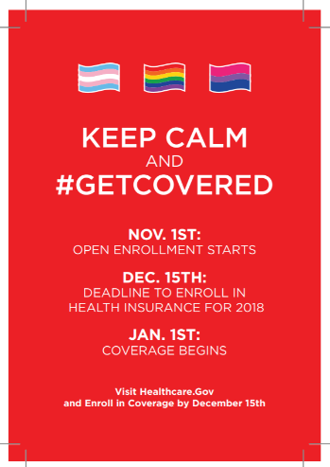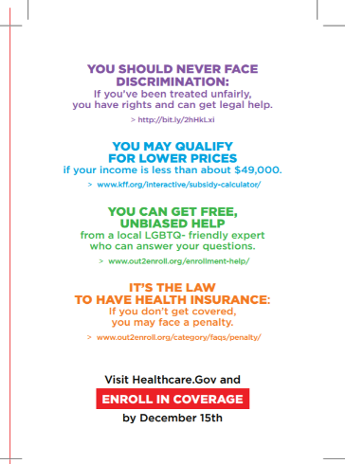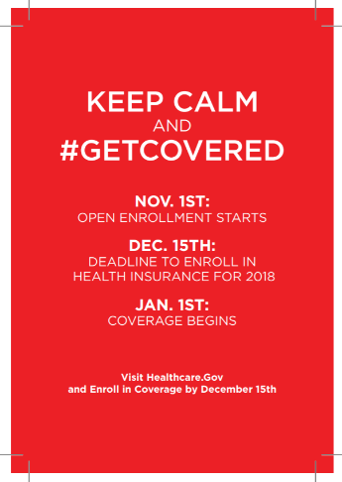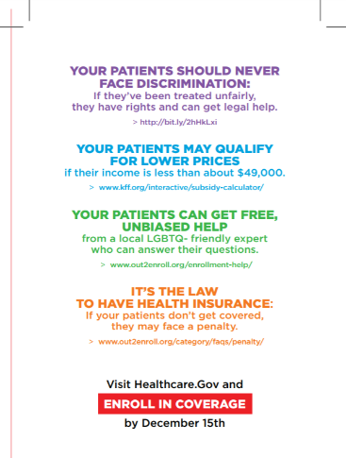
Social Media Shareables
These social media shareables and other images are available at: https://drive.google.com/drive/folders/0B-m6BmC2gCOiUTdSM2FJTVp0aE0?usp=sharing. Many of this year’s materials are unbranded, making it easier for any organization to use them freely. We will also plan to update the Google drive on a regular basis to add more graphics as they’re developed.

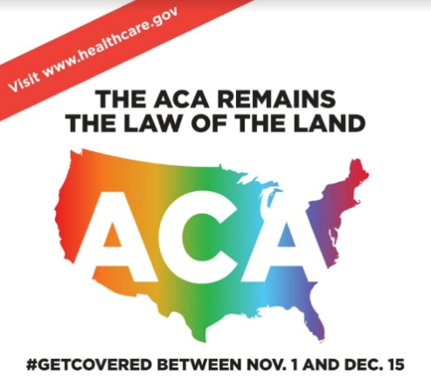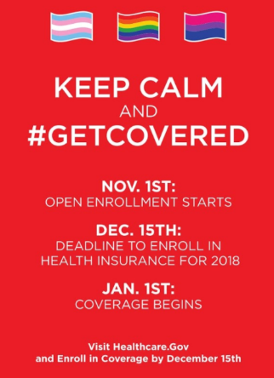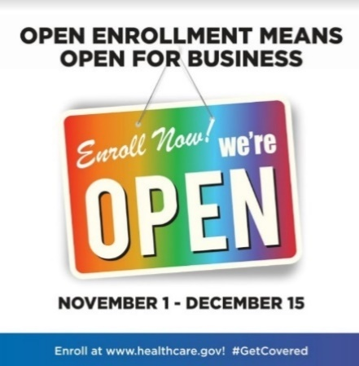

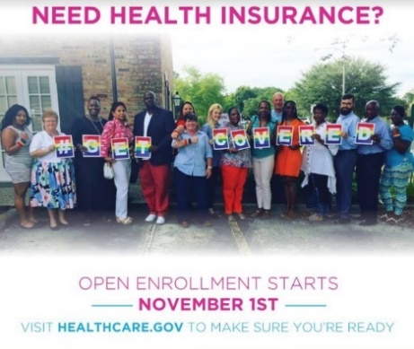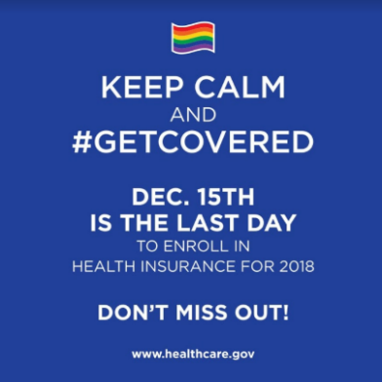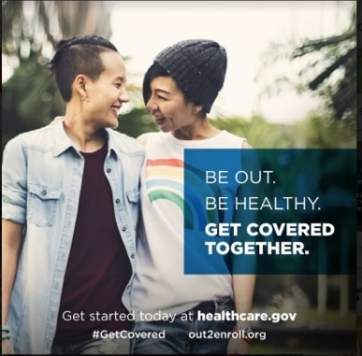

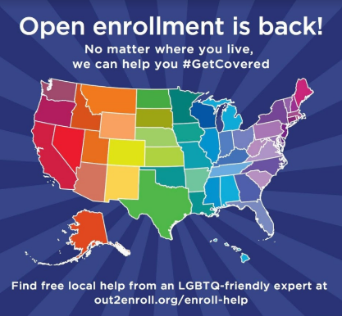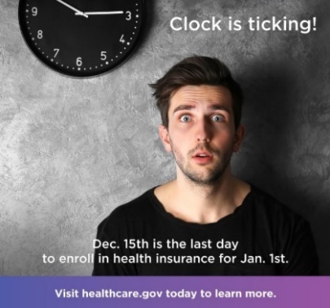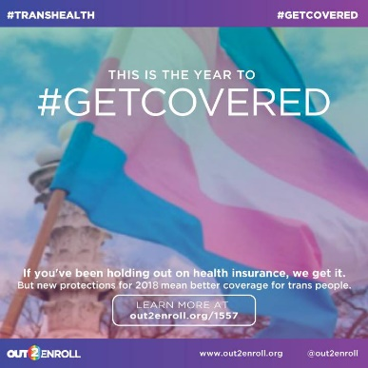

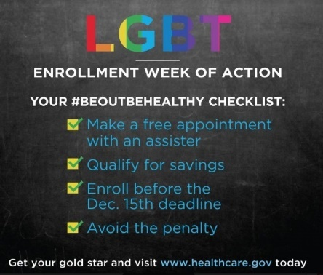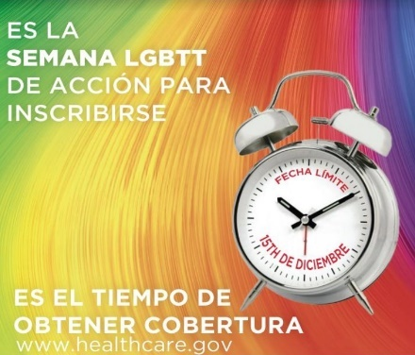

Sample Social Media Posts
“The marketplaces are open for business for 2018.”
- Open enrollment is BACK and healthcare.gov is open for business! Do you qualify for lower prices on health insurance for 2018? Visit healthcare.gov NOW to explore your options and #GetCovered! #EnrollByDec15
- It’s that time of year again – open enrollment is back! From now until Dec. 15th, you can find health insurance that fits your needs and your budget for 2018. Visit healthcare.gov today to see if you qualify for a discount #GetCovered #EnrollByDec15
- Got questions about health care? We’ve got you covered. The marketplaces are open for 2018! Time to shop for health insurance that works for you. Make sure you and your loved ones #GetCovered at healthcare.gov before the December 15th deadline #EnrollByDec15
- Waiting to enroll in health insurance? The wait is over. Visit healthcare.gov today to compare plans, shop for the best prices, avoid the penalty, and #GetCovered #EnrollByDec15
- Open enrollment is ON! Shop for health insurance that fits your budget and your life. Sign on, check out your options, and make sure to enroll by Dec. 15th so you can start 2018 off right #ReadySetEnroll #GetCovered #EnrollByDec15
- Millions have health insurance thanks to the Affordable Care Act, including many LGBTQ people. Now that open enrollment is BACK, make sure you and your loved ones #GetCovered at healthcare.gov before the December 15th deadline #EnrollByDec15
- Healthcare.gov is OPEN for business with new plans and new prices! #GetCovered TODAY before the Dec 15 deadline! #EnrollByDec15
- It's that time of year again - open enrollment is back! From now until Dec. 15th, you can save money and #GetCovered for 2018 #EnrollByDec15
- Waiting to enroll in health insurance? The wait is over. Visit healthcare.gov NOW to shop and save! #GetCovered #EnrollByDec15
- Need health insurance? RUN, DON'T WALK to healthcare.gov to find a plan that fits your life and your budget #EnrollByDec15
- Open enrollment means open for all, incl LGBTQ+ people & friends! Spread the word and #GetCovered at healthcare.gov #EnrollByDec15

“The final deadline to enroll is December 15th.”
- DYK: the final deadline to get health insurance for 2018 is on Dec. 15th?!? This is a change from last year so make sure you have a plan to get the coverage you need before it’s too late. No need to put it off – #GetCovered TODAY at healthcare.gov #EnrollByDec15
- Don’t delay, enroll today! Healthcare.gov is open for business for 2018 but open enrollment is shorter this year – the final deadline is Dec. 15th. Don’t be one of those people who waits til it’s almost too late. Visit healthcare.gov today to #GetCovered and give yourself peace of mind #EnrollByDec15
- Tick tock, tick tock…we’re getting closer to the FINAL DEADLINE to enroll in health insurance through healthcare.gov. The LAST DAY to enroll is Dec. 15th – so don’t get stuck in line or miss your chance. Visit healthcare.gov today to get started and give yourself the peace of mind you need #EnrollByDec15
- DYK: the FINAL deadline to get health insurance for 2018 is on Dec. 15th? #GetCovered TODAY at healthcare.gov #EnrollByDec15
- Don’t delay, enroll today! The deadline is Dec. 15th but avoid the rush and #GetCovered today at healthcare.gov #EnrollByDec15
- Tick tock, tick tock. We're getting closer to the FINAL deadline to #GetCovered at healthcare.gov Don't miss out! #EnrollByDec15

“Health plans and prices change every year—and the amount of financial help you can get may change too.”
- Worried about costs? Health plans and prices change every year and you could SAVE BIG by SIGNING ON to healthcare.gov to check out your options. Fill out the application, see if you qualify for a discount, and find a deal TODAY #GetCovered #EnrollByDec15
- We know health insurance can be expensive – but it doesn’t have to be at healthcare.gov! That’s the only place where you can get a discount on your health insurance. Sign on today to see if you qualify and shop around for the best deal #GetCovered #EnrollByDec15
- Enrolling in health insurance is cheaper and easier than you think – head to healthcare.gov today to SHOP and SAVE on health insurance for 2018! #GetCovered #EnrollByDec15
- Do you qualify for a discount on health insurance? Most people do! Visit healthcare.gov TODAY to see if you qualify #EnrollByDec15
- Enrolling in health insurance is cheaper & easier than you think! Visit healthcare.gov now to SHOP & SAVE for 2018! #EnrollByDec15
- Health insurance doesn't have to break the bank - visit healthcare.gov today to see if you qualify for a discount! #EnrollByDec15

“HealthCare.gov offers free help and personal assistance.”
- Need help with your health insurance? Worried about how much it will cost? You're not alone! Connect today with LGBTQ-friendly experts FOR FREE to make sure you're getting the best deal and saving the most money. Find someone in your area today at: www.out2enroll.org/enrollment-help #EnrollByDec15
- Getting health insurance is easier than ever at healthcare.gov! But we know you've still got questions - if you need a little help, check out our free in-person LGBT-friendly assisters in your area. Make an appointment today before it’s too late: www.out2enroll.com/enrollment-help #GetCovered #EnrollByDec15
- Only [X] more days to #GetCovered by the December 15th deadline. If you need a little help, we've got you covered! Free in-person experts are available atout2enroll.org/enrollment-help #EnrollByDec15
- No need to stress about health insurance - we can help! Free queer-friendly help is available at http://www.out2enroll.org/enrollment-help ! #EnrollByDec15
- Ready to shop for health insurance? Want extra help? Visit http://www.out2enroll.org/enrollment-help to find a FREE LGBTQ-friendly expert #EnrollByDec15
- Need trans-affirming answers to health insurance questions? Connect w/ a trans friendly expert at http://www.out2enroll.org/enrollment-help #EnrollByDec15

“LGBTQ people are protected from discrimination in health care and health insurance.”
- Got questions about what protections you have when it comes to health care? Nothing has changed—the Affordable Care Act STILL protects all LGBTQ people from discrimination in health insurance and health care. Enroll now at healthcare.gov before it’s too late #KnowYourRights and #GetCovered #EnrollByDec15
- You should never face discrimination simply for being who you are. Enroll in health insurance at healthcare.gov TODAY with the confidence of knowing that health insurance companies can’t discriminate against you for being LGBTQ #KnowYourRights #GetCovered #EnrollByDec15
- All LGBTQ people are protected from discrimination when it comes to health insurance and health care. Not sure what that means? We've got answers! Just make sure you take advantage of these new protections by enrolling in health insurance at healthcare.gov before December 15th. It's never been more important! #KnowYourRights #GetCovered #EnrollByDec15
- You should NEVER face discrimination no matter who you are or where you live. Enroll with confidence at healthcare.gov #EnrollByDec15
- Want to resist Trump & help yourself? Get health insurance at healthcare.gov. You need it (& it'll drive him crazy) #EnrollByDec15

“Health insurance is better than ever for transgender people who can expect more and demand more.”
- #TransHealth matters. Thanks to the Affordable Care Act, transgender and genderqueer people should never be discriminated against in health insurance or care. That means access to the free preventive care and transition-related care you need—and the right to be treated with respect by health care providers. Enroll now at healthcare.gov before it’s too late #KnowYourRights #GetCovered #EnrollByDec15
- We know it can be difficult to find the health insurance you need, especially when it comes to transition-related care. BUT marketplace plan coverage is better than ever before. Enroll now at healthcare.gov before it’s too late #KnowYourRights #GetCovered #EnrollByDec15
- NEW nondiscrimination protections for #LGBTQ people mean NO MORE #trans exclusions & better coverage. Enroll today healthcare.gov
- Want to take action to protect #TransHealth? Get health insurance at healthcare.gov. Plans are better than ever #EnrollByDec15
- You have the right to the care you need and the respect you deserve, especially when it comes to #TransHealth #GetCovered today.

