Suggested Messaging Calendar

To help streamline social media efforts, we have developed the following week-by-week messaging recommendations. These are not exhaustive, and you should feel free to supplement them with your own materials and messaging that resonates with the communities you serve. The images below (and many more!) are available here. Most are unbranded so you can add your logo if you want – we will plan to update the Google drive on a regular basis to add more graphics as they are developed. Feel free to schedule these into your Facebook and Twitter accounts ahead of time so you can set it and forget it!

Week 1 (Sun, Oct. 27 to Sat, Nov. 2) - we also have a series of “countdown” graphics to November 1st
Pre-OE7 | Facebook | It’s our favorite time of year – open enrollment begins again on Nov. 1st! Make sure you’re ready by visiting HealthCare.gov today to update your information #GetCovered | 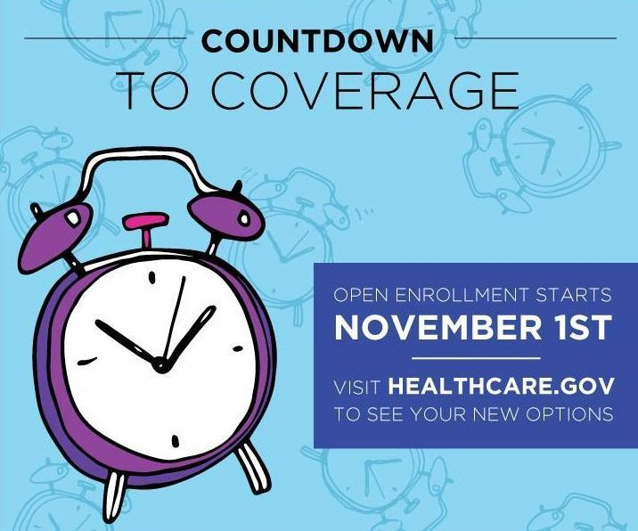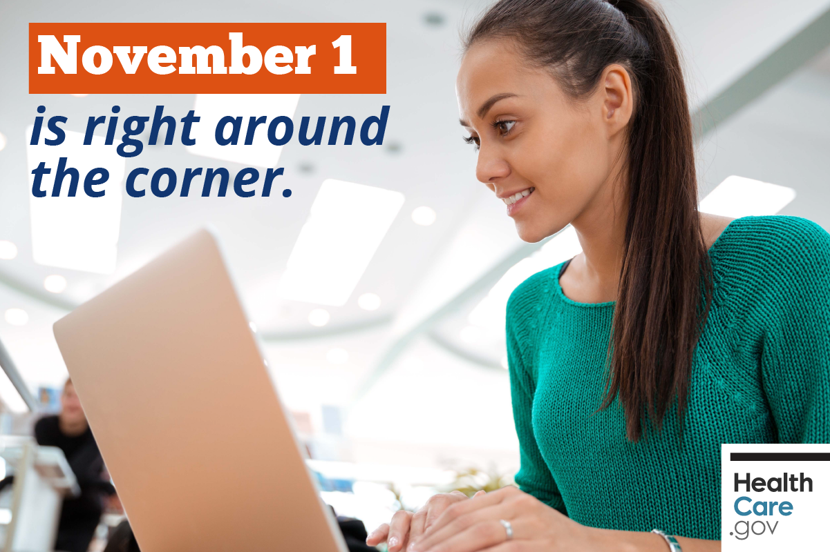
 | Twitter | It’s our favorite time of year: open enrollment is BACK on Nov. 1st! Visit HealthCare.gov today to update your info #GetCovered
*Halloween*  (Thursday Oct 31st) | Facebook | Don't let the cost of an injury scare you this year – HealthCare.gov is OPEN for business tomorrow. You can shop around for a new plan or renew your current one. Shop and save with new options, new prices, and financial help #GetCovered #EnrollByDec15 | 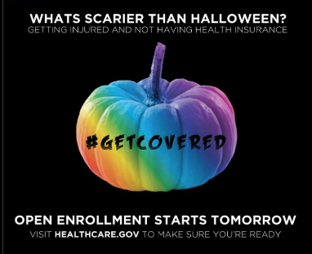
 | Twitter | What's scarier than Halloween? Being uninsured! Visit HealthCare.gov TOMORROW and find a plan that fits your needs and your budget
Nov 1st  (Friday) | Facebook | Open enrollment is BACK and HealthCare.gov is open for business! Do you qualify for lower prices on health insurance for 2020? Visit HealthCare.gov NOW to explore your options and #GetCovered! #EnrollByDec15 | 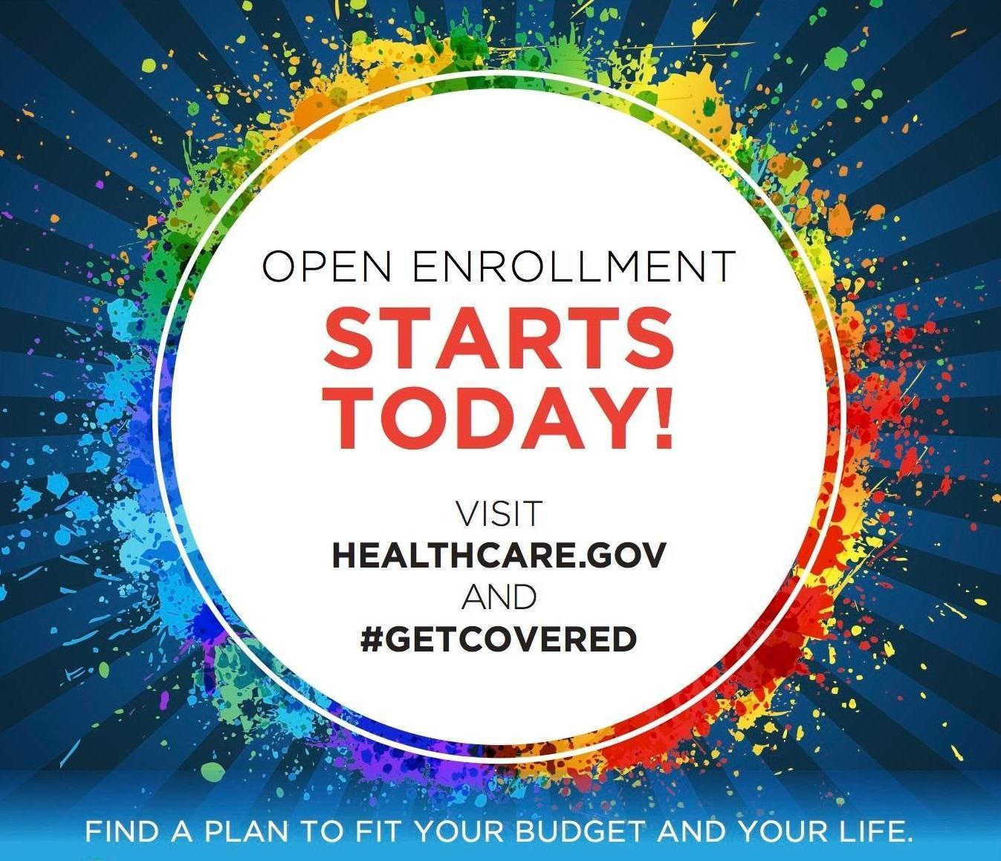
 | Twitter | HealthCare.gov is OPEN for business with new plans and new prices! #GetCovered TODAY before the Dec 15 deadline! #EnrollByDec15
Open for business | Facebook | It’s that time of year again – open enrollment is back! From now until Dec. 15th, you can find health insurance that fits your needs and your budget for 2020. Visit HealthCare.gov today to see if you qualify for a discount #GetCovered #EnrollByDec15 | 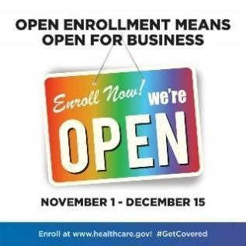
 | Twitter | It's that time of year again - open enrollment is back! From now until Dec. 15th, you can save money and #GetCovered for 2020. Visit HealthCare.gov and #EnrollByDec15

Week 2 (Sun, Nov. 3 to Sat, Nov. 9) - we know this is election week so there may be less enrollment-related messaging
Financial help | Facebook | Enrolling in health insurance is cheaper and easier than you think – head to HealthCare.gov today to SHOP and SAVE on health insurance for 2020! #GetCovered #EnrollByDec15 | 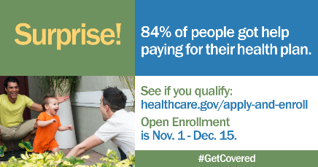
 | Twitter | Enrolling in health insurance is cheaper & easier than you think! Visit HealthCare.gov now to SHOP & SAVE for 2020! #EnrollByDec15
In-person help | Facebook | Getting health insurance is easier than ever at HealthCare.gov! But we know you've still got questions - if you need a little help, check out our free in-person LGBTQ-friendly assisters in your area. Make an appointment today before it’s too late: out2enroll.org/enrollment-help #GetCovered #EnrollByDec15 | 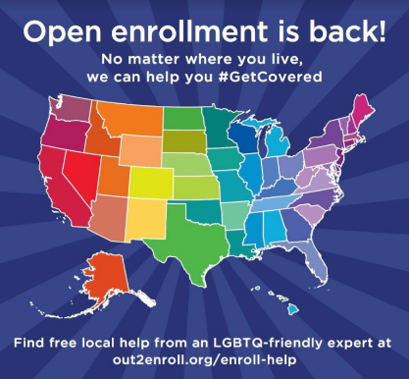
 | Twitter | Ready to shop for health insurance at HealthCare.gov? Need extra help? Visit out2enroll.org/enrollment-help to find a FREE LGBTQ-friendly expert to help you #GetCovered #EnrollByDec15

Week 3 (Sun, Nov. 10 to Sat, Nov. 16)
Open enrollment includes LGBTQ people | Facebook | Millions have health insurance thanks to the Affordable Care Act, including many LGBTQ people. Now that open enrollment is BACK, make sure you and your loved ones #GetCovered at HealthCare.gov before the December 15th deadline #EnrollByDec15 | 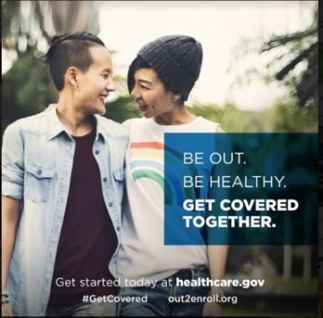
 | Twitter | Open enrollment means open for all, including LGBTQ people & families! Spread the word and #GetCovered at HealthCare.gov #EnrollByDec15
OE7 is on | Facebook | Got questions about health insurance? We’ve got you covered. HealthCare.gov is officially open for 2020 and it’s time to shop for health insurance that works for you. Just do it before December 15th #EnrollByDec15 | 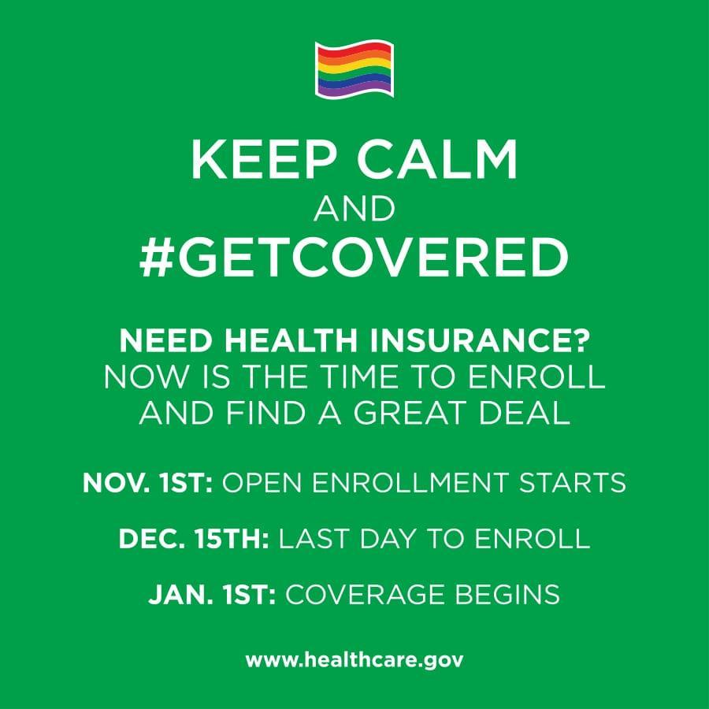
 | Twitter | It's that time of year again - open enrollment is back! From now until Dec. 15th, you can save money and #GetCovered for 2020. Visit HealthCare.gov and #EnrollByDec15
Dec 15th deadline | Facebook | Don’t delay, enroll today! HealthCare.gov is open for business for 2020 but open enrollment is short this year – the final deadline is Dec. 15th. Don’t be one of those people who waits until it’s almost too late. Visit HealthCare.gov today to #GetCovered and give yourself peace of mind #EnrollByDec15 | 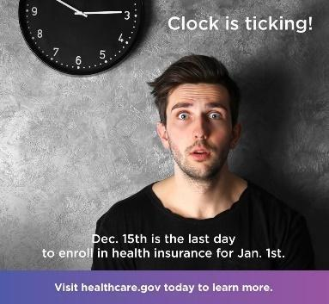
 | Twitter | Don’t delay, enroll today! The deadline is Dec. 15th but avoid the rush and #GetCovered today at HealthCare.gov #EnrollByDec15

Week 4 (Sun, Nov. 17 to Sat, Nov. 23)
In-person help | Facebook | Need help with your health insurance? You're not alone! Connect today with LGBTQ-friendly experts FOR FREE to make sure you're getting the best deal and saving the most money. Find someone in your area today at out2enroll.org/enrollment-help #EnrollByDec15 | 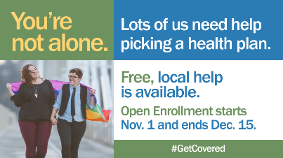
 | Twitter | No need to stress about health insurance - we can help! Free queer-friendly help is available at out2enroll.org/enrollment-help #EnrollByDec15
*Trans Day of Remembrance*  (WEDNESDAY, Nov 20) | Facebook | Today is Transgender Day of Remembrance. We stand together to honor and remember all those we have lost #TDOR #TransVisibility | 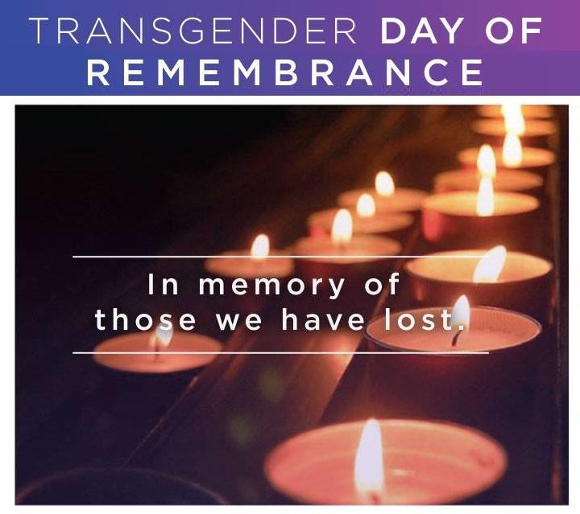
 | Twitter | Today is Transgender Day of Remembrance. We stand together to honor and remember all those we have lost #TDOR #TransVisibility
Non-  discrimination | Facebook | Got questions about health care? Nothing has changed—the Affordable Care Act STILL protects all LGBTQ people from discrimination in health insurance and health care. Enroll now at HealthCare.gov before it’s too late #KnowYourRights and #GetCovered #EnrollByDec15 | 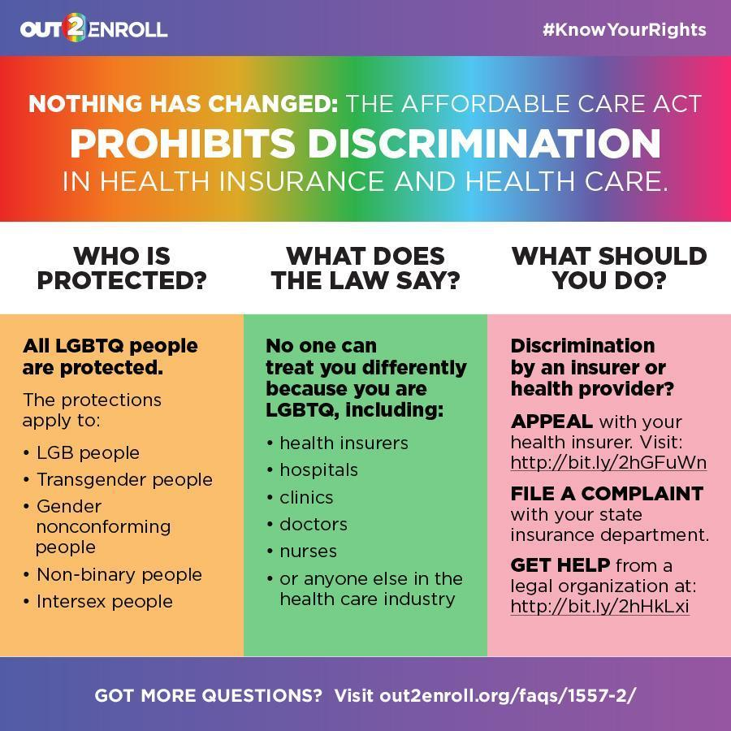
 | Twitter | You should NEVER face discrimination no matter who you are or where you live. Enroll with confidence at HealthCare.gov #EnrollByDec15
Financial help | Facebook | Worried about costs? Health plans and prices change every year and you could SAVE BIG at HealthCare.gov. See if you qualify for a discount and find a deal TODAY #GetCovered #EnrollByDec15 | 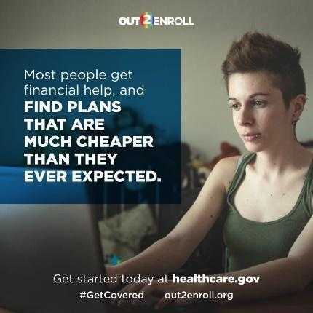
 | Twitter | Do you qualify for a discount on health insurance? Most people do! Visit HealthCare.gov TODAY to see if you qualify #EnrollByDec15

Week 5 (Sun, Nov. 24 to Sat, Nov. 30)
Deadline | Facebook | Tick tock, tick tock…we’re getting closer to the FINAL DEADLINE to enroll in health insurance through HealthCare.gov. The LAST DAY to enroll is Dec. 15th – so don’t get stuck in line or miss your chance. Visit HealthCare.gov today to get started and give yourself the peace of mind you need #EnrollByDec15 | 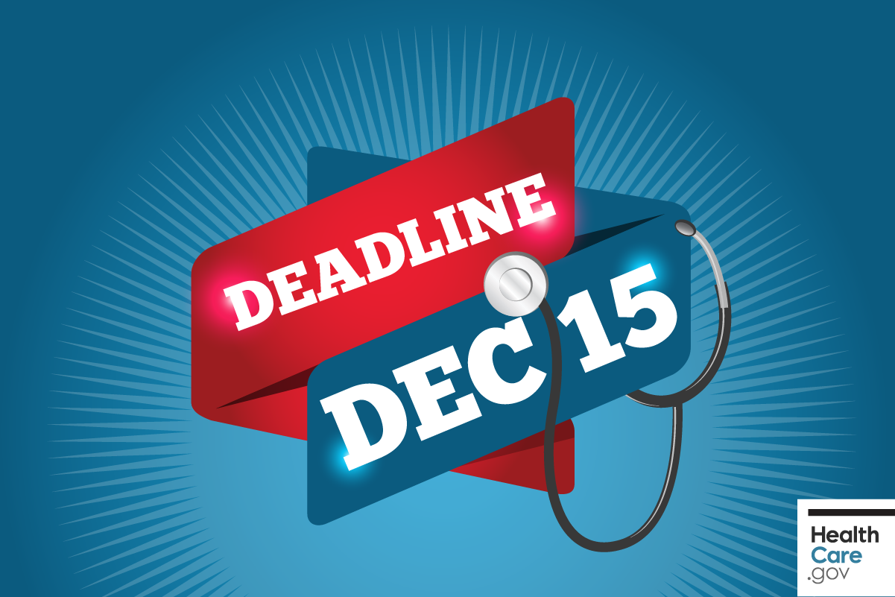
 | Twitter | Tick tock, tick tock. We're getting closer to the FINAL deadline to #GetCovered at HealthCare.gov Don't miss out! #EnrollByDec15
*Thanksgiving*  (Thursday Nov 28) | Facebook | This year, we’re thankful for the Affordable Care Act which has helped more LGBTQ people than ever before have health insurance and more affirming health care. Make sure you and your family - chosen or otherwise - #GetCovered at HealthCare.gov before it's too late! #EnrollByDec15 | 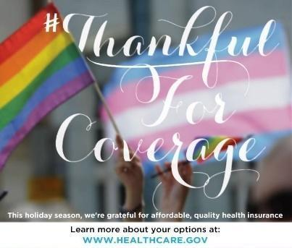
 | Twitter | Need health insurance this holiday season? You're in luck...but only until the Dec. 15th deadline at HealthCare.gov #GetCovered
In-person help  (Friday,  Nov 30) | Facebook | Only 15 more days to #GetCovered by the December 15th deadline. If you need a little help, we've got you covered! Free experts are available at out2enroll.org/enrollment-help #EnrollByDec15 | 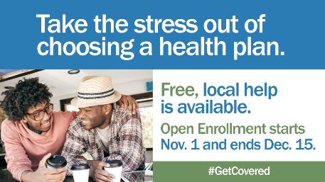
 | Twitter | Ready to shop for health insurance? Need extra help? Visit out2enroll.org/enrollment-help to find a FREE LGBTQ-friendly expert #EnrollByDec15

Week 6 (Sun, Dec. 1 to Sat, Dec. 7) – LGBTQ Enrollment Week of Action
Week of action  (SUNDAY, Dec 1) | Facebook | It’s #LGBTQ Enrollment Week of Action! This is the best time of year for our community to #GetCovered and save money before the Dec.15th deadline. It's cheaper and easier than ever to get health insurance! Visit HealthCare.gov TODAY #EnrollByDec15  Es La Semana LGBTT de Acción para Inscribirse. Es el tiempo de obtener cobertura para 2020! Visite cuidadodesalud.gov antes de la fecha límite - 15 de diciembre. #GetCovered! | 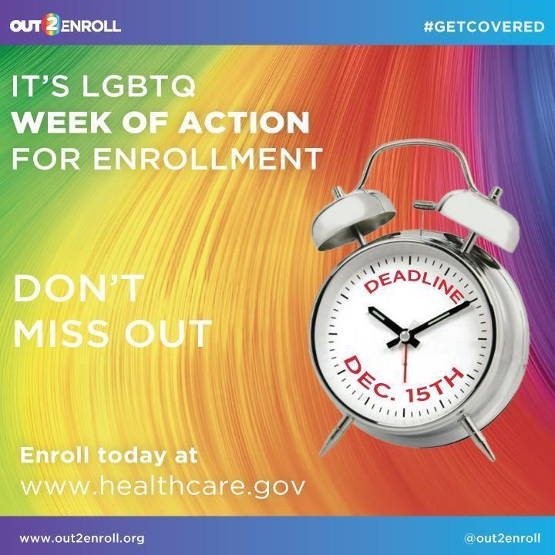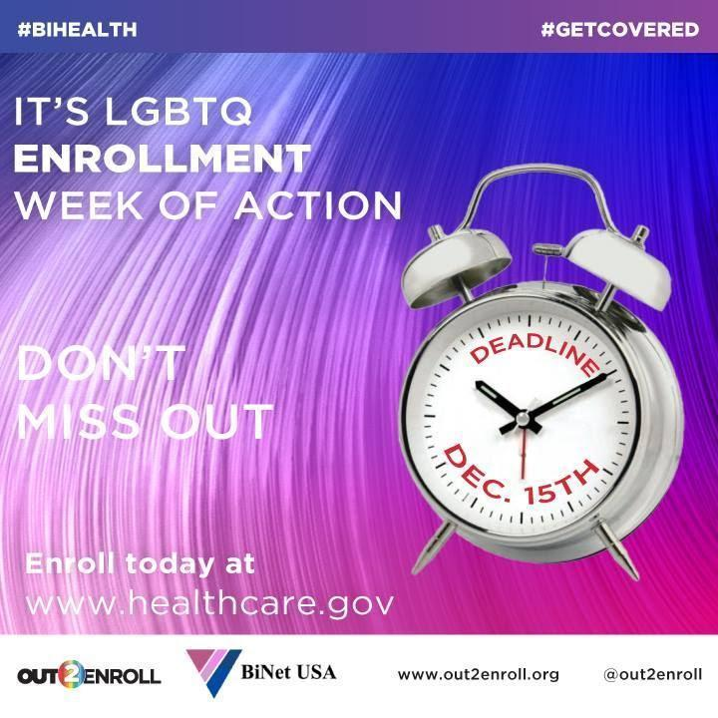  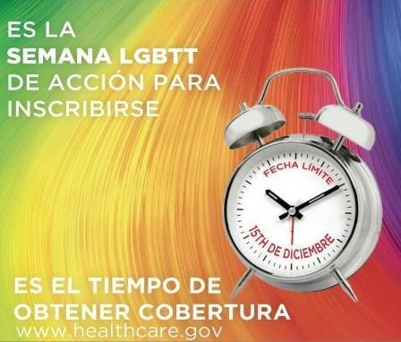
 | Twitter | LGBTQ Enrollment Week of Action is the best time to #GetCovered and save money before the Dec 15 deadline #EnrollByDec15  Es La Semana LGBTT de Acción para Inscribirse. Es el tiempo de obtener cobertura para 2020! Visite cuidadodesalud.gov antes de la fecha límite - 15 de diciembre. #GetCovered!
In-person help (MONDAY, Dec 2) | Facebook | Need help finding health insurance? Worried about how much it will cost? You're not alone! Let our free, unbiased LGBTQ-friendly experts make sure you're getting the best deal and saving the most money by the Dec. 15th deadline. Schedule an appointment today at out2enroll.org/enrollment-help #GetCovered #EnrollByDec15 | 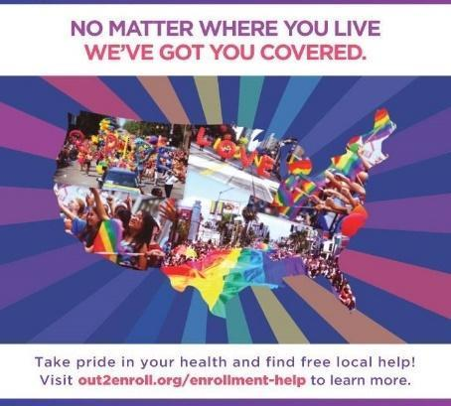
 | Twitter | Need LGBTQ-affirming answers to health insurance questions? Connect with a queer-friendly expert at out2enroll.org/enrollment-help #EnrollByDec15
Deadline (TUESDAY, Dec 3) | Facebook | Open enrollment is ON! Shop for health insurance that fits your budget and your life. Sign on to HealthCare.gov, check out your options, and make sure to enroll TODAY so you can start 2020 off right #GetCovered #EnrollByDec15 | 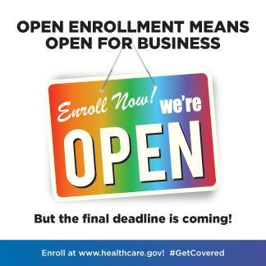
 | Twitter | Need health insurance? RUN, DON'T WALK to HealthCare.gov to find a plan that fits your life and your budget #EnrollByDec15
Enroll now (WEDNESDAY, Dec 4) | Facebook | Making your holiday list and checking it twice? Don't forget health insurance! #GetCovered for 2020 at HealthCare.gov before the Dec. 15th deadline #EnrollByDec15 | 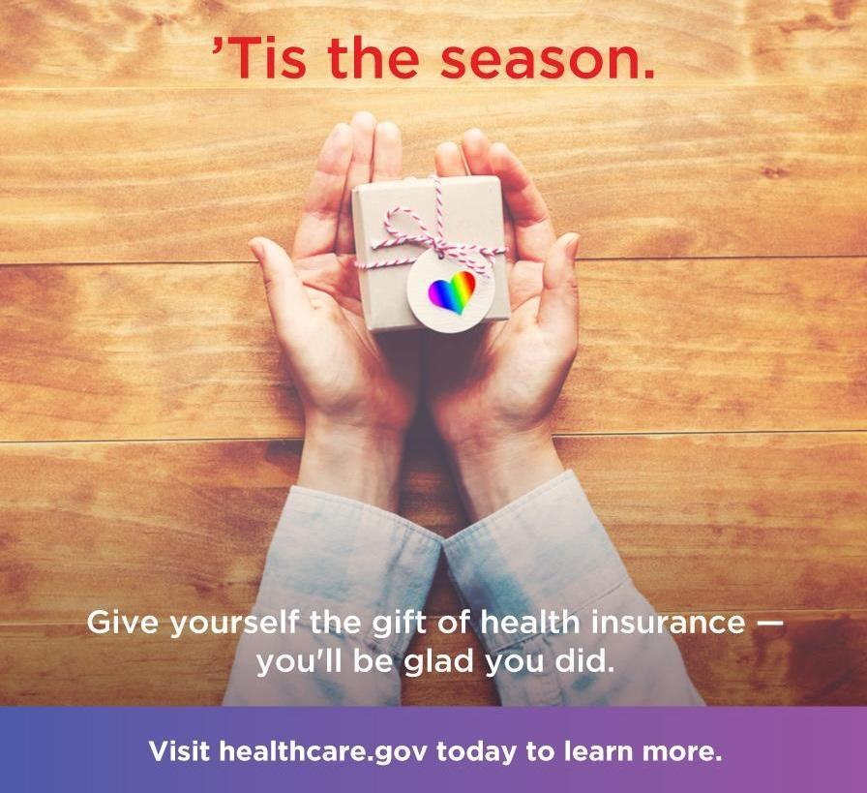
 | Twitter | Making a holiday list & checking it twice? Don't forget health insurance at HealthCare.gov by Dec. 15th! #GetCovered #EnrollByDec15
Trans coverage options (THURSDAY, Dec 5) | Facebook | #TransHealth matters. Thanks to the Affordable Care Act, transgender and genderqueer people should never be discriminated against in health insurance or health care. That means access to the free preventive care and transition-related care you need—and the right to be treated with respect by health care providers. Enroll now at HealthCare.gov before it’s too late #KnowYourRights #GetCovered #EnrollByDec15 | 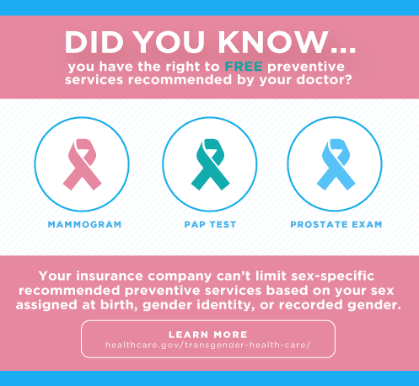
 | Twitter | You have the right to the care you need and the respect you deserve, especially when it comes to #TransHealth. Visit HealthCare.gov to #GetCovered TODAY!
LGBTQ disparities (FRIDAY, Dec 6) | Facebook | We've got a lot of work to do when it comes to health insurance for bi+, queer, and trans folks in our community. Don't be a statistic - visit HealthCare.gov TODAY to #GetCovered before the Dec. 15th deadline #EnrollByDec15 | 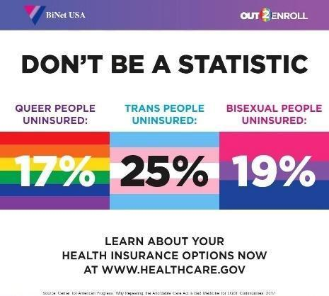
 | Twitter | Why do we want you to #GetCovered? Because our community needs it! Visit HealthCare.gov TODAY #EnrollByDec15
Deadline (SATURDAY, Dec 7) | Facebook | DYK: the final deadline to get health insurance for 2020 is Dec. 15th?!? Make sure you have a plan to get the coverage you need before it’s too late. No need to put it off – #GetCovered TODAY at HealthCare.gov #EnrollByDec15 | 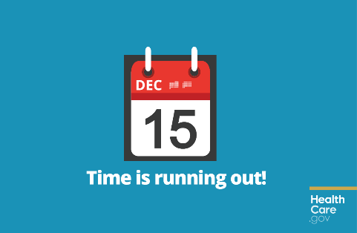
 | Twitter | Don’t delay, enroll today! The deadline is Dec. 15th but avoid the rush and #GetCovered TODAY at HealthCare.gov #EnrollByDec15

Week 7 (Sun, Dec. 8 to Sat, Dec. 14)
Deadline (SUNDAY, Dec 8) | Facebook | ONE WEEK left until the December 15th deadline for health insurance! This is your LAST opportunity to #GetCovered for 2020 – don’t miss out on financial help and the coverage you need. Visit HealthCare.gov NOW #EnrollByDec15 | 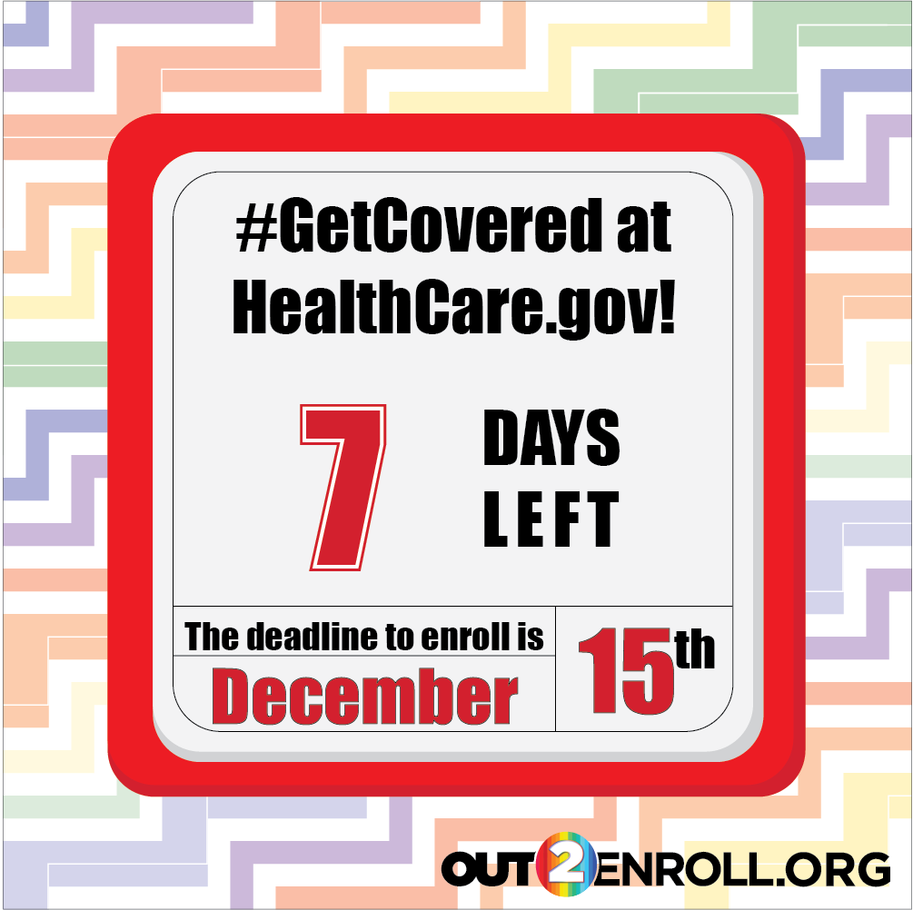
 | Twitter | With one week until Dec. 15th deadline, TODAY is the perfect day to get started and #GetCovered at HealthCare.gov #EnrollByDec15
Deadline (MONDAY, Dec 9) | Facebook | 6 days left until the December 15th deadline for health insurance! This is your LAST opportunity to #GetCovered for 2020 – don’t miss out on financial help and the coverage you need. Visit HealthCare.gov NOW #EnrollByDec15 | 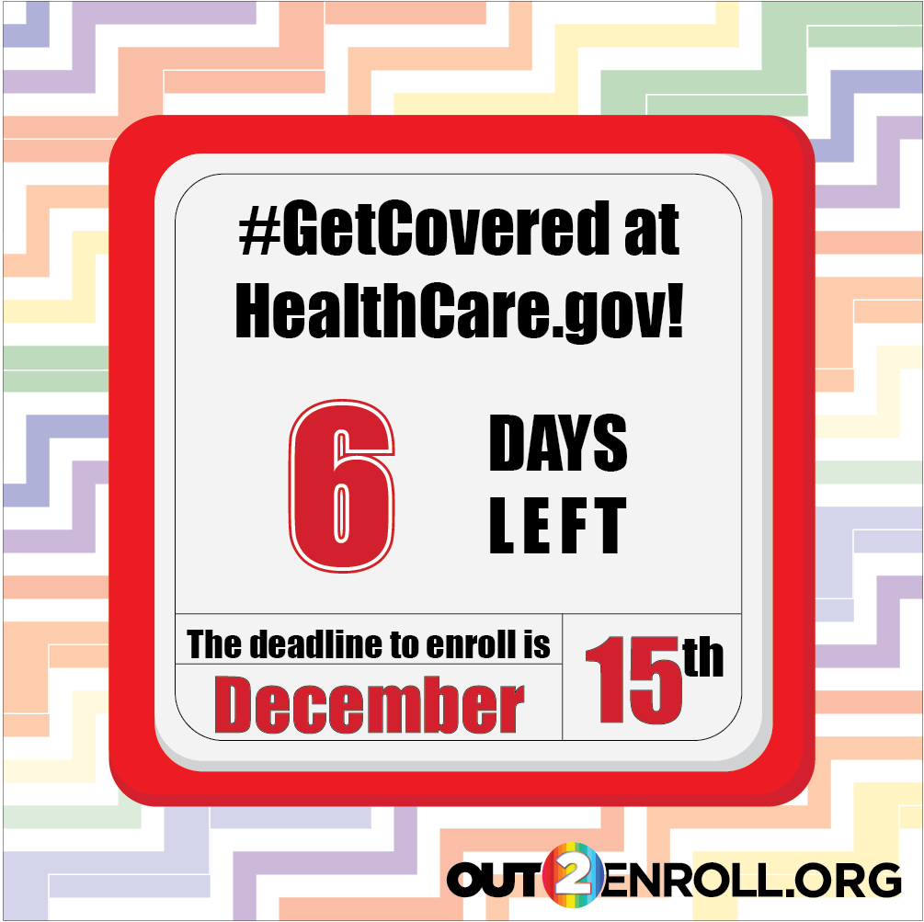
 | Twitter | With 6 days until Dec. 15th deadline, TODAY is the perfect day to get started and #GetCovered at HealthCare.gov #EnrollByDec15
Deadline (TUESDAY, Dec 10) | Facebook | 5 days left until the December 15th deadline for health insurance! This is your LAST opportunity to #GetCovered for 2020 – don’t miss out on financial help and the coverage you need. Visit HealthCare.gov NOW #EnrollByDec15 | 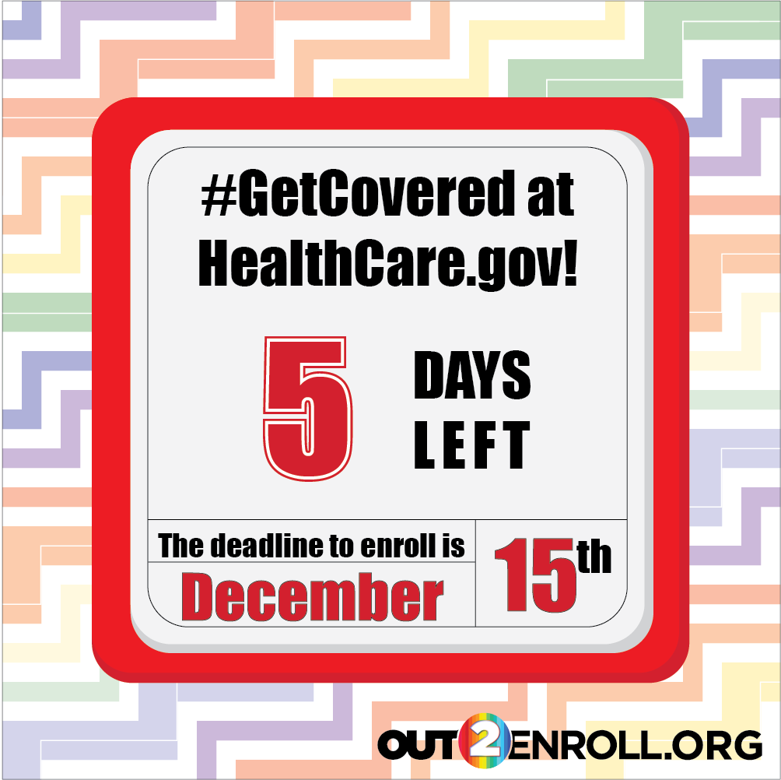
 | Twitter | With 5 days until Dec. 15th deadline, TODAY is the perfect day to get started and #GetCovered at HealthCare.gov #EnrollByDec15
Deadline (WEDNESDAY, Dec 11) | Facebook | Only 4 more days to #GetCovered by the Dec. 15th deadline – if you or your loved ones are uninsured or enrolled before, NOW is the time to head to HealthCare.gov. You may qualify for a discount and the health insurance is better than ever! #EnrollByDec15 | 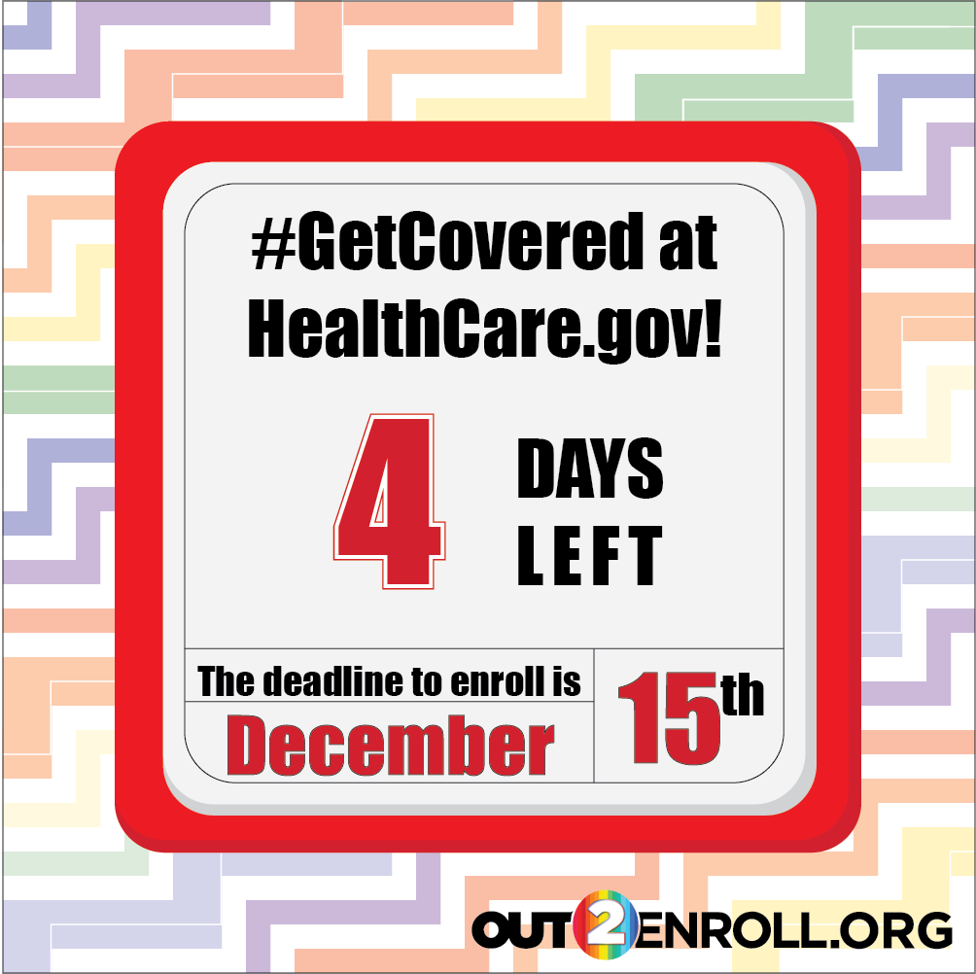
 | Twitter | Only 4 days to #GetCovered by the Dec. 15 deadline. Don't miss out - run, don't walk, to HealthCare.gov TODAY #EnrollByDec15
Deadline (THURSDAY, Dec 12) | Facebook | Time is running out! Dec. 15th is the FINAL deadline to enroll in health insurance for 2020. Go to HealthCare.gov NOW and make sure you get the coverage you need before it’s too late #EnrollByDec15 | 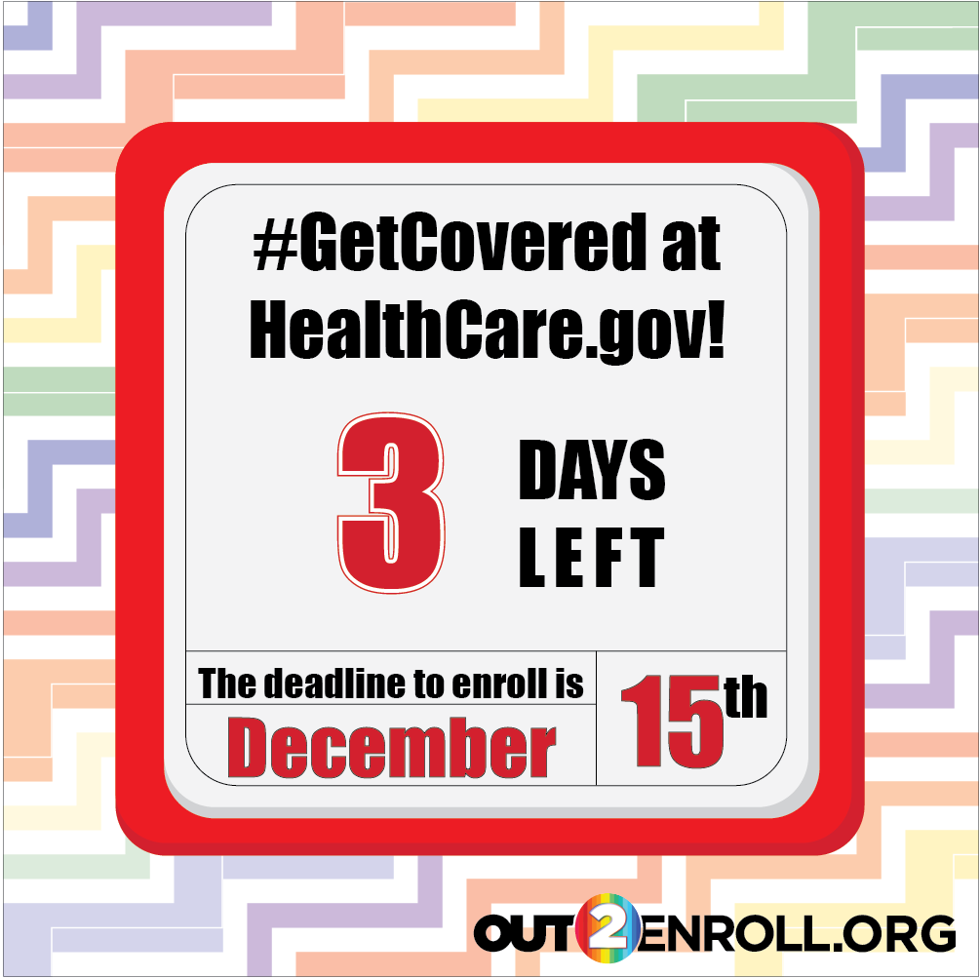
 | Twitter | Time is running out! Only 3 more days until the Dec. 15th deadline - visit HealthCare.gov NOW to #GetCovered #EnrollByDec15
Deadline (FRIDAY, Dec 13) | Facebook | JUST TWO DAYS LEFT. The FINAL deadline to enroll is Dec. 15th. If you need health insurance, run – don’t walk – to HealthCare.gov to enroll today! It’s easier and cheaper than ever before – don’t miss out #EnrollByDec15 | 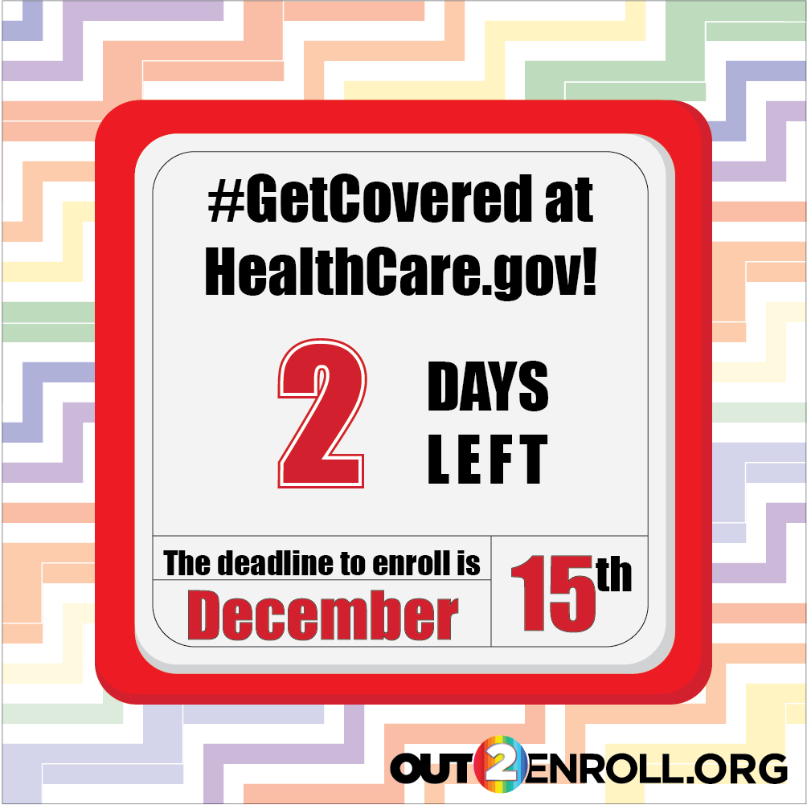
 | Twitter | Just 2 days left until Dec 15 deadline for health insurance. Today is the day to #GetCovered at HealthCare.gov #EnrollByDec15
Deadline (SATURDAY, Dec 14) | Facebook | Still need health insurance? The deadline is almost here – visit HealthCare.gov NOW to avoid lines and wait times and #GetCovered for 2020 #EnrollByDec15 | 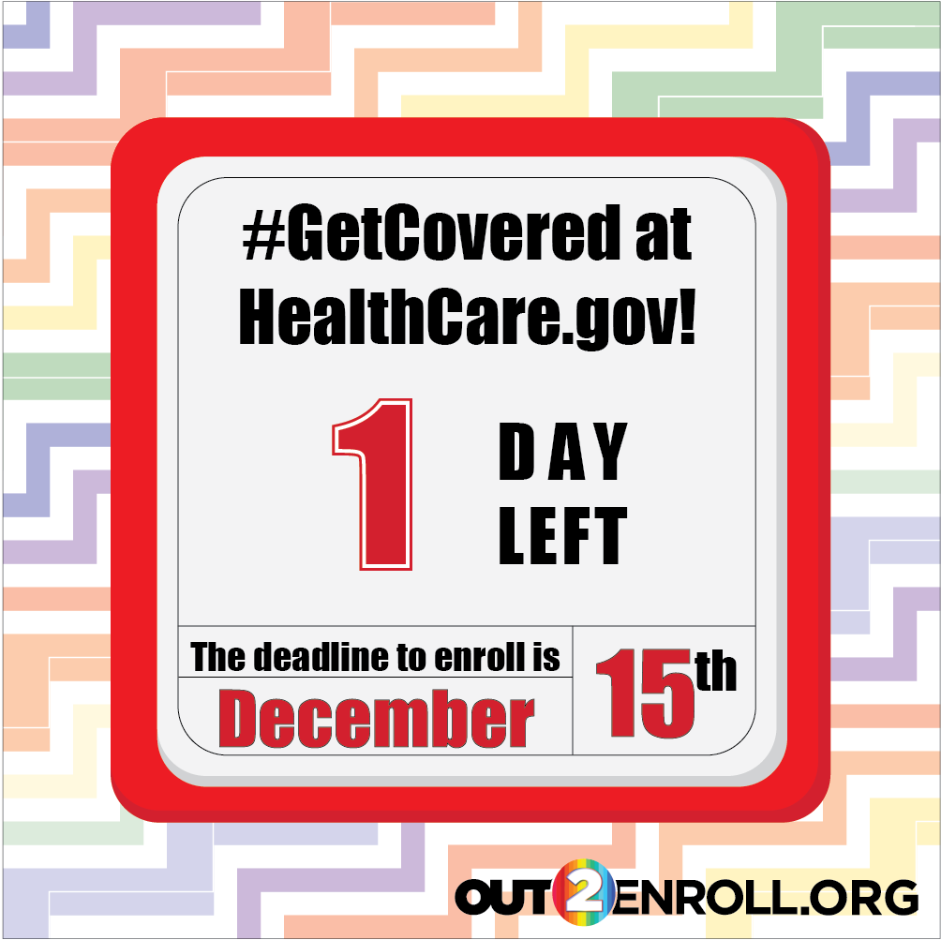
 | Twitter | TICK TOCK. Tomorrow is the LAST DAY to enroll in health insurance for 2020. Avoid lines - go to HealthCare.gov NOW #EnrollByDec15

Week 8 (Sun, Dec. 15)
Deadline  (SUNDAY,  Dec 15) | Facebook | TODAY is the FINAL deadline for health insurance! This is your LAST CHANCE to enroll so don’t miss out! Visit HealthCare.gov NOW to #GetCovered #EnrollByDec15 | 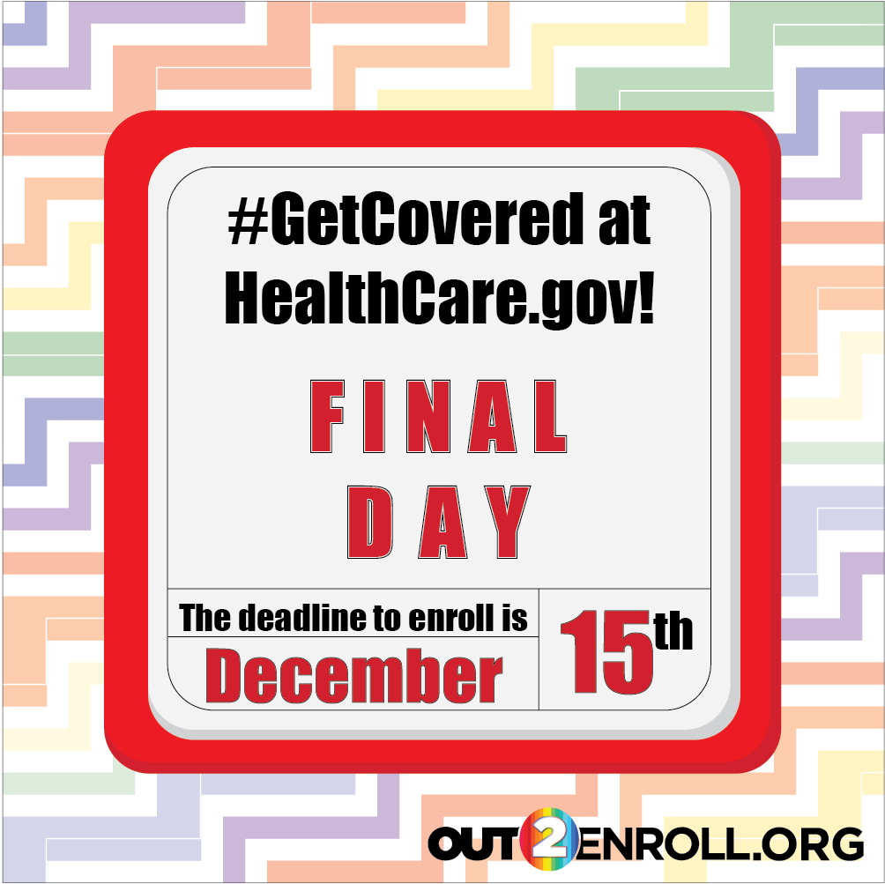
 | Twitter | TODAY is the DEADLINE! Need health insurance? This is your last chance to enroll at HealthCare.gov #GetCovered #EnrollByDec15

