Out2Enroll Partners,
Thank you so much for joining us for another year of open enrollment. We are grateful that you have taken the pledge to share enrollment information and resources with the communities you serve. As you know, we have made tremendous progress in advancing LGBTQ health: the uninsured rate among low- and middle-income LGBTQ people has dropped by an overwhelming 35% since 2013.
But there’s much more work to do to maintain this progress and protect our communities in the era of Trump. Sadly, the rate of uninsurance went up last year for the first time since Obamacare passed in 2010. As this administration continues to undermine the Affordable Care Act — slashing budgets for outreach, advertising, and in-person enrollment assistance — it is up to us to get the word out and make sure people get covered.
Your voice is more important than ever, and this work is essential to making sure LGBTQ people:
- Know their rights when it comes to nondiscrimination in insurance and health care;
- Use healthcare.gov to browse insurance plans;
- Qualify for financial help and lower premiums; and
- Sign up for health insurance by December 15th.
As in previous years, we have developed graphics, messaging, and sample social media posts to make sharing content hassle-free. Feel free to incorporate these messages into your own posts or use them as is. You can even schedule posts ahead of time so you never have to worry: set it and forget it!
Thank you for joining Out2Enroll and our partners across the country in helping LGBTQ people get covered!
Out2Enroll
Hashtags: #GetCovered, #EnrollByDec15, #BeOutBeHealthy, #KnowYourRights
Key Dates
- FRIDAY, Nov. 1st: Marketplaces open!
- Nov. 3rd to Nov. 9th: Latinx and Immigrant Week of Action
- Nov. 10th to Nov. 16th: African American Week of Action
- Nov. 17th to Nov. 23rd: People with Disabilities Week of Action & Rural Health Week
- Nov. 24th to Nov. 30th: Faith Week of Action, Thankful Week (Thanksgiving 11/28)
- Dec. 1st to Dec. 7th: LGBTQ Enrollment Week of Action, AAPI Week of Action, & Men’s Health Week
  - Dec. 1st: World AIDS Day
  - Dec. 6th: National Youth Enrollment Day
- Dec. 8th to Dec. 15th: Young Adult Week & Women’s Health Week
- SUNDAY, Dec. 15th: Final enrollment deadline* for 2020 coverage at healthcare.gov!
*Some states with their own marketplaces may have extended their open enrollment periods, but the dates vary—please double check the enrollment deadline for your state’s marketplace and remember that to have coverage that begins on Jan 1st, you must enroll by Dec 15th.
CA | Oct 15, 2019 - Jan 15, 2020 | MA | Nov 1, 2019 - Jan 23, 2020 | RI | Nov 1, 2019 - Dec 31, 2019
CO | Nov 1, 2019 - Jan 15, 2020 | MN | Nov 1, 2019 - Dec 23, 2019
DC | Nov 1, 2019 - Jan 31, 2020 | NY | Nov 1, 2019 - Jan 31, 2020

Key Messages
In light of the confusion of previous years, message testing shows that the best messages are informational and demonstrate confidence and stability in the marketplaces. We must let people know that the marketplaces are once again “open for business” for 2020 coverage. To make it even easier this year, check out our week-by-week messaging guidance (attached and here). These messages are:
- “The marketplaces are open for business for 2020.” With Trump’s efforts to undermine the ACA, consumers are understandably confused about where things stand. Many continue to think that the ACA will be repealed even though premiums are dropping in many states. Keep messaging apolitical, informative, and confident in the marketplace:
  - “Healthcare.gov is open for business!”
  - “You can still find health insurance that meets your needs and your budget.”
  - “You may qualify for a discount on health insurance in 2020.”
- “Nothing has changed: LGBTQ people are protected from discrimination in health care and health insurance.” Although LGBTQ people are under attack by the Trump administration, it is important to remind the community that nothing has changed when it comes to health care. People still have access to financial help for health insurance and should continue to pay their premiums—and Section 1557’s nondiscrimination protections are still in place.
  - “You should never face health discrimination simply for being who you are.”
  - “Stand up for your right to health insurance and health care!”
- “The final deadline to enroll is December 15th.” For consumers who use the marketplace, the open enrollment period has become normalized but lost in the fray so we must remind consumers about the deadline.
  - “It’s that time of year again – don’t miss out on health insurance for 2020!”
  - “December 15th is the final deadline to enroll in health insurance for 2020!”
- “Health plans and prices change every year—and the amount of financial help you can get may change too. Visit HealthCare.gov today!” Affordability remains the biggest focus and challenge for returning consumers and the uninsured alike. Many simply won’t enroll if coverage costs too much. Financial help is also the best way to make a distinction between the marketplaces (since consumers can only get subsidies through HealthCare.gov).
  - “HealthCare.gov is the ONLY place you can get financial help”
  - “Even if you’ve looked before, it’s time to check out your options and find the plan that’s right for you.”
- “HealthCare.gov offers the most comprehensive coverage.” The Trump administration has touted non-Obamacare plans that do not cover preexisting conditions and will likely discriminate against our community. These plans are NOT acceptable alternatives to the high-quality coverage you can find at HealthCare.gov. We need to continue to regularly push HealthCare.gov as the ONLY place to find high-quality, affordable plans to make sure our community avoids Trump’s junk plans and gets the financial protection they deserve.
  - “Make sure you’re getting the best insurance - visit HealthCare.gov today”
  - “If you’re not visiting HealthCare.gov, you could be missing out on health insurance that covers everything you need.”
  - “Plans offered at HealthCare.gov cover comprehensive benefits like preventive care, check-ups, prescriptions, mental health care, birth control, and more.”
- “HealthCare.gov offers free help and personal assistance.” Consumers are twice as likely to complete enrollment if they receive in-person help, and 80% of LGBTQ people want to meet with an assister that understands LGBTQ-specific issues. Consumers can find free in-person help using our locator tool: http://www.out2enroll.org/enrollment-help.
  - “Signing up at HealthCare.gov is easier than ever.”
  - “You can get FREE in-person LGBTQ-friendly help to enroll in health insurance.”
- “Health insurance is better than ever for transgender people who can expect more and demand more.” Too few trans people have had real health insurance options because of discriminatory exclusions. But the ACA’s protections still apply to 2020 health insurance plans, so marketplace plans should NOT have transgender exclusions.
  - “Got questions about transition-related care? When you enroll at HealthCare.gov, transition-related health care should be covered.”
  - “DYK that coverage is better than ever for trans people?! Check out your options today at HealthCare.gov!”

Printable Materials
These print-ready postcards are available here. Feel free to print them yourself or let us know (ben@out2enroll.org) what you’d like and we’ll print and send them to you for free!
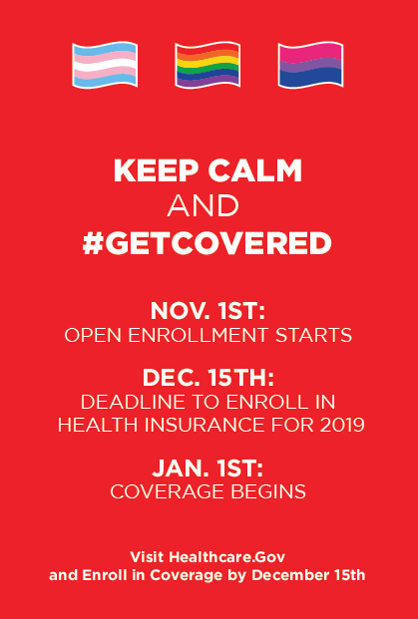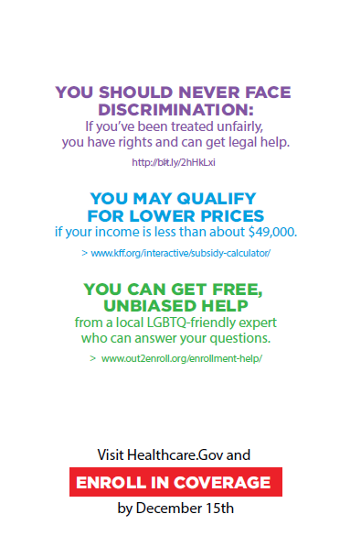
Social Media Shareables
These social media shareables and other images are available here. Many of this year’s materials are unbranded, making it easier for any organization to use them freely. We also plan to update the Google drive on a regular basis to add more graphics as they are developed.
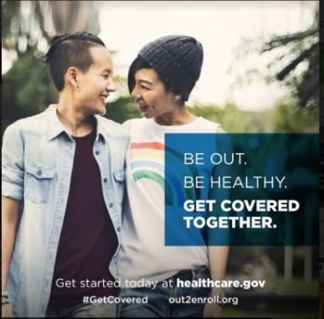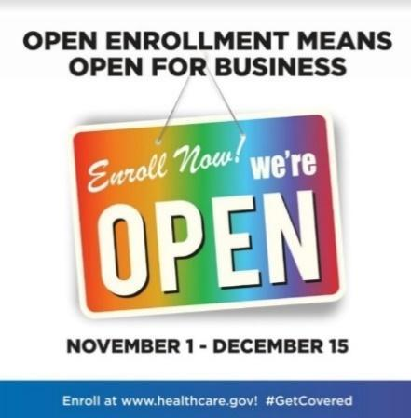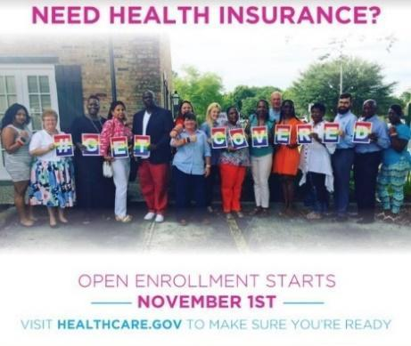

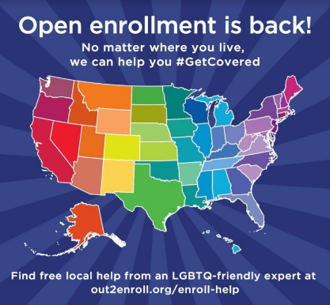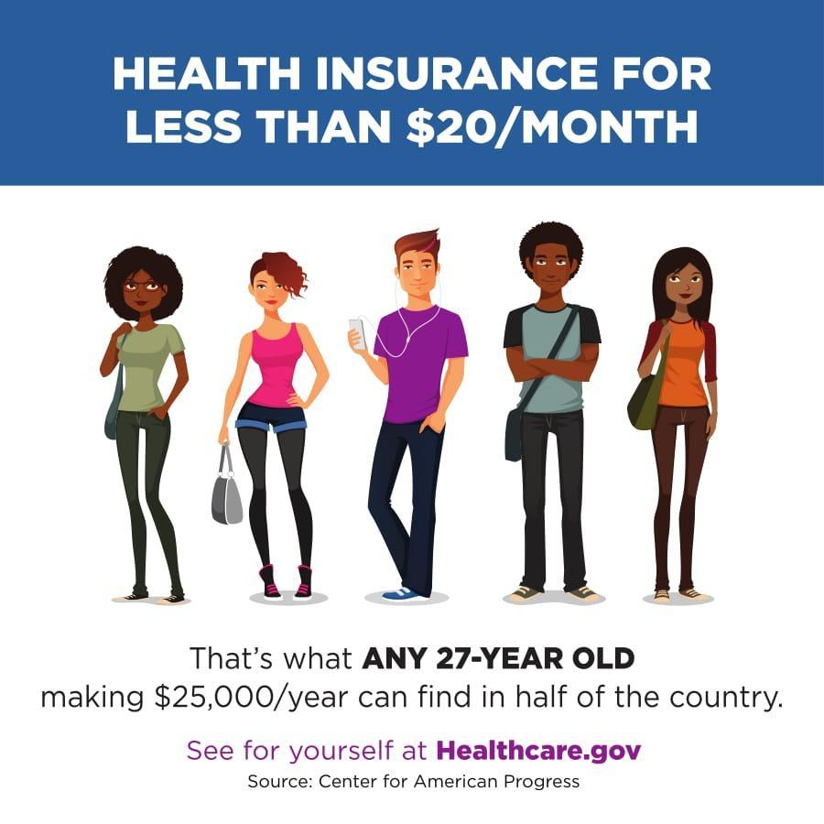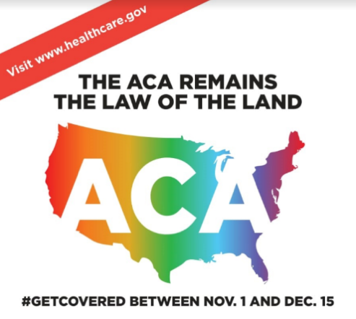

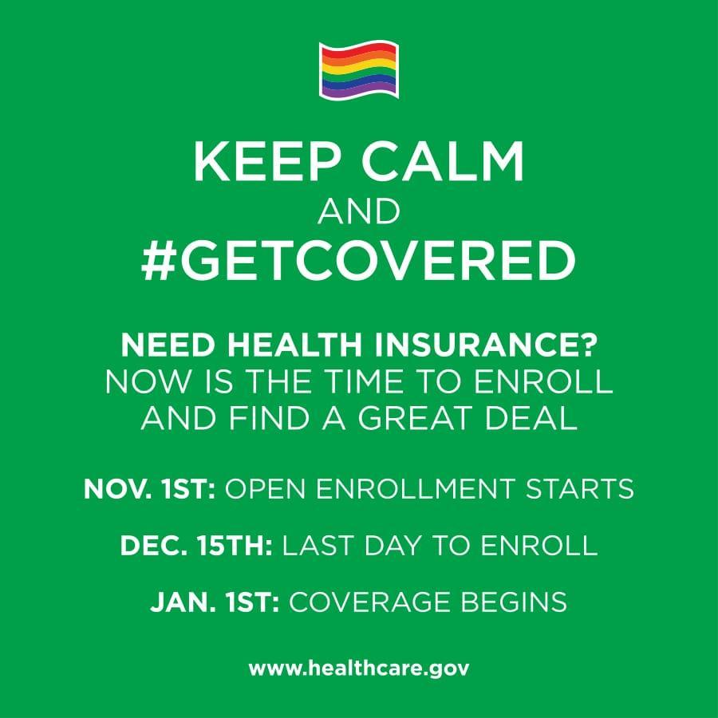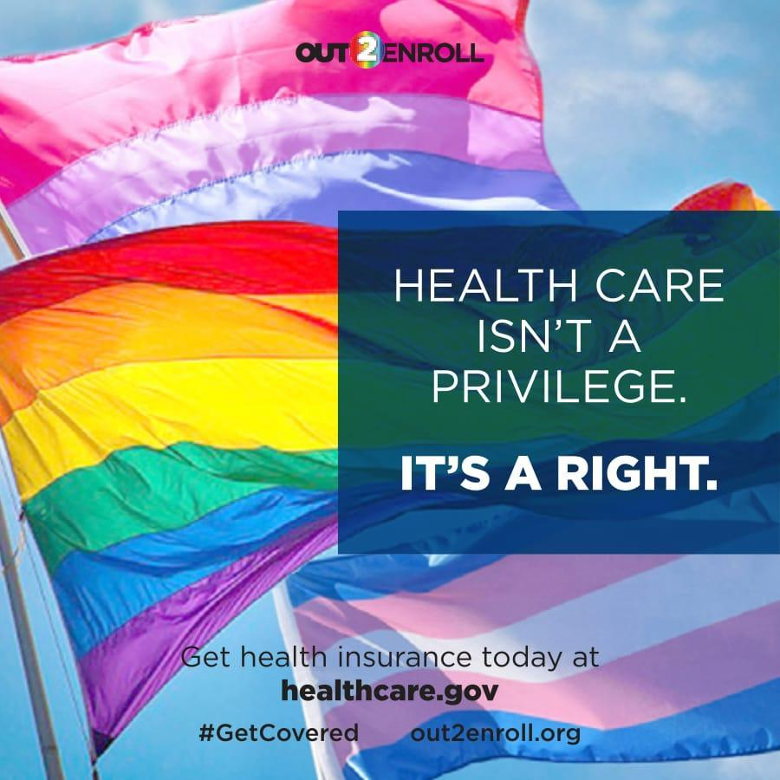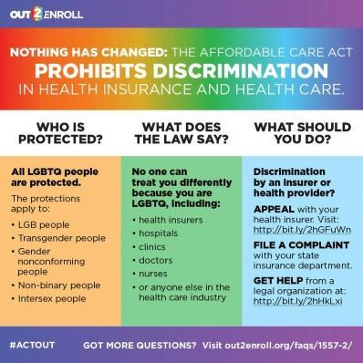

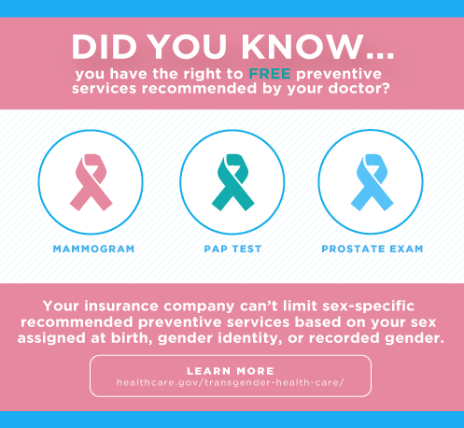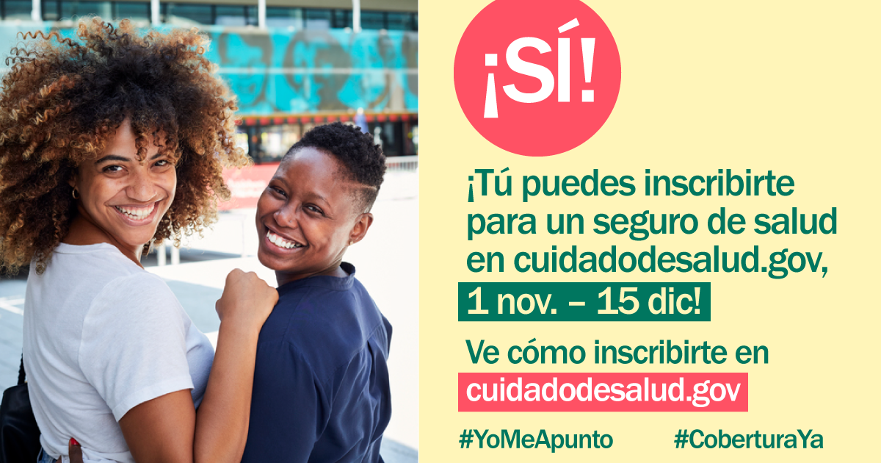

Sample Social Media Posts
“The marketplaces are open for business for 2020.” Hashtags: #EnrollByDec15 #ReadySetEnroll
- Open enrollment is BACK and HealthCare.gov is open for business! Do you qualify for lower prices on health insurance for 2020? Visit HealthCare.gov NOW to explore your options and #GetCovered! #EnrollByDec15
- It’s that time of year again – open enrollment is back! From now until Dec. 15th, you can find health insurance that fits your needs and your budget for 2020. Visit HealthCare.gov today to see if you qualify for a discount #GetCovered #EnrollByDec15
- Got questions about health insurance? We’ve got you covered – Go to HealthCare.gov TODAY to shop for health insurance that works for you. Make sure you and your loved ones #GetCovered before the December 15th deadline #EnrollByDec15
- Open enrollment is ON! Shop for health insurance that fits your budget and your life. Visit HealthCare.gov, check out your options, and #EnrollByDec15 so you start 2020 off right #ReadySetEnroll #GetCovered
- Millions now have health insurance thanks to the Affordable Care Act, including many LGBTQ people. Make sure you #GetCovered at HealthCare.gov before the December 15th deadline #EnrollByDec15
- HealthCare.gov is OPEN for business with new plans and new prices! #GetCovered TODAY before the December 15th deadline! #EnrollByDec15
- Open enrollment means open for ALL, including LGBTQ people and families! Spread the word and #GetCovered at HealthCare.gov before it’s too late #EnrollByDec15

“The final deadline to enroll is December 15th.” Hashtags: #EnrollByDec15 #GetCovered
- DYK: the final deadline to get health insurance for 2020 is on Dec. 15th?!? Make sure you get the coverage you need before it’s too late. Don’t put it off – visit HealthCare.gov TODAY #EnrollByDec15
- HealthCare.gov is open for business for 2020 – but only until Dec. 15th. Give yourself peace of mind by visiting HealthCare.gov today #EnrollByDec15
- Tick tock, tick tock…we’re getting closer to the FINAL DEADLINE to enroll in health insurance. The LAST DAY is Dec. 15th – so don’t miss your chance! Visit HealthCare.gov today to get started and give yourself peace of mind #EnrollByDec15
- DYK the FINAL deadline to get health insurance for 2020 is on Dec. 15th? #GetCovered TODAY at HealthCare.gov #EnrollByDec15
- Don’t delay, enroll today! The deadline is Dec. 15th but you can avoid the rush and #GetCovered TODAY at HealthCare.gov #EnrollByDec15
- Nobody likes waiting in line. Avoid the rush by signing up for health insurance TODAY at HealthCare.gov. #GetCovered #EnrollByDec15

“Health plans and prices change every year—and the amount of financial help you can get may change too.” Hashtags: #EnrollByDec15 #GetCovered
- DYK: last year, 87% of people qualified for lower monthly premiums. Visit HealthCare.gov now to SHOP & SAVE for 2020! #GetCovered #EnrollByDec15
- DYK: last year, 8 in 10 people found health insurance for less than $100 a month. Visit HealthCare.gov today to see how affordable coverage really is. #EnrollByDec15
- Don’t be fooled by a junk plan with low premiums and limited coverage. HealthCare.gov is the only place to find comprehensive plans to protect your health and your wallet. Find the best bang for your buck & #GetCovered TODAY at HealthCare.gov. #EnrollByDec15.
- Worried about costs? Health plans and prices change every year and you could SAVE BIG. Sign on to HealthCare.gov to check out your options and find a deal TODAY #GetCovered #EnrollByDec15
- Health insurance can be expensive – but it doesn’t have to be! HealthCare.gov is the ONLY place you can get a discount on your health insurance. See if you qualify and shop around for the best deal #GetCovered #EnrollByDec15
- Health insurance is cheaper than you think – head to HealthCare.gov today to SHOP and SAVE on health insurance for 2020! #GetCovered #EnrollByDec15
- Do you qualify for a discount on health insurance? Most people do! Visit HealthCare.gov TODAY to see how affordable it is for you to #GetCovered. #EnrollByDec15
- Enrolling in health insurance is cheaper & easier than you think! Visit HealthCare.gov now to SHOP & SAVE for 2020! #EnrollByDec15
- Health insurance doesn't have to break the bank - visit HealthCare.gov today to see if you qualify for a discount! #EnrollByDec15

“HealthCare.gov offers free help and personal assistance.” Hashtags: #EnrollByDec15
- Need help finding health insurance? Worried about how much it will cost? You're not alone! Connect today with a FREE LGBTQ-friendly expert to make sure you're getting the best deal on coverage. Visit out2enroll.org/enrollment-help and #EnrollByDec15 at HealthCare.gov.
- Getting health insurance is easier than ever at HealthCare.gov! But if you've still got questions, find a FREE in-person LGBTQ-friendly assister in your area. Make an appointment today at out2enroll.com/enrollment-help and #GetCovered before it’s too late! #EnrollByDec15
- Only [X] more days to #GetCovered at HealthCare.gov! If you need a little help, we've got your back! Free in-person or over-the-phone experts are available at out2enroll.org/enrollment-help #EnrollByDec15
- No need to stress about health insurance – we can help! Free queer-friendly help is available at out2enroll.org/enrollment-help! #EnrollByDec15 at HealthCare.gov.
- Ready to shop for health insurance at HealthCare.gov? Need extra help? Visit out2enroll.org/enrollment-help to talk to a FREE LGBTQ-friendly expert to help you #GetCovered #EnrollByDec15
- Need answers to your trans-related health insurance questions before you choose a HealthCare.gov plan? We can help! Connect for FREE with a trans-friendly expert at out2enroll.org/enrollment-help and #EnrollByDec15

“LGBTQ people are protected from discrimination in health care and health insurance.” Hashtags: #EnrollByDec15 #KnowYourRights
- We know the headlines can be scary when it comes to health care and being LGBTQ. But our community is still protected from discrimination in health insurance, at the hospital or clinic, and with our doctors. You should never be disrespected simply for being who you are #KnowYourRights and enroll in health insurance at HealthCare.gov before it’s too late #EnrollByDec15
- Got questions about your rights in health care? Nothing has changed—the Affordable Care Act STILL protects all LGBTQ people from discrimination in health insurance and health care. Enroll now at HealthCare.gov before it’s too late #EnrollByDec15 #KnowYourRights
- You should never face discrimination for being who you are. Enroll in health insurance at HealthCare.gov TODAY knowing that health insurance companies can’t discriminate against you for being LGBTQ #KnowYourRights #GetCovered #EnrollByDec15
- All LGBTQ people are protected from discrimination in health insurance and health care. What does that mean? Learn more at out2enroll.org/category/faqs/discrimination/ and #GetCovered at HealthCare.gov before Dec. 15th #KnowYourRights #EnrollByDec15
- You should NEVER face discrimination no matter who you are or where you live. Enroll with confidence at HealthCare.gov #EnrollByDec15

“Health insurance is better than ever for transgender people who can expect more and demand more.” Hashtags: #EnrollByDec15 #KnowYourRights #TransHealth
- #TransHealth matters! Thanks to the ACA, trans & GQ ppl are protected from discrimination in health insurance & care. That means access to the transition-related care you need & the right to be treated with respect. #KnowYourRights & #EnrollByDec15 at HealthCare.gov
- We know it can be frustrating to find the health insurance you need, especially for transition-related care. But marketplace plans are better than ever before. Enroll with confidence at HealthCare.gov - before it’s too late #KnowYourRights #EnrollByDec15
- Nondiscrimination protections for #LGBTQ people mean NO #trans exclusions & better coverage. Enroll with confidence at HealthCare.gov. #EnrollByDec15
- You have the right to the care you need and the respect you deserve, especially when it comes to #TransHealth #GetCovered TODAY at HealthCare.gov. #EnrollByDec15

