LGBTQ Enrollment Week of Action Social Media Toolkit for OE7
Thanks for celebrating LGBTQ Enrollment Week of Action! The purpose of this week—which runs from December 1st to 7th—is to maximize outreach, engagement, and enrollment of LGBTQ communities ahead of the December 15th enrollment deadline. Out2Enroll and partners across the country will use this week to promote the importance of LGBTQ community engagement and enrollment, educate LGBTQ consumers about their rights under the Affordable Care Act, and help ensure that LGBTQ people are able to access the health coverage and care they need. This week also coincides with Men’s Health Week, AAPI Enrollment Week of Action, World AIDS Day (December 1st), and National Youth Enrollment Day (December 6th).
Hashtags: #GetCovered, #EnrollByDec15, #TransHealth, #KnowYourRights
These and other images are available on our Google drive.
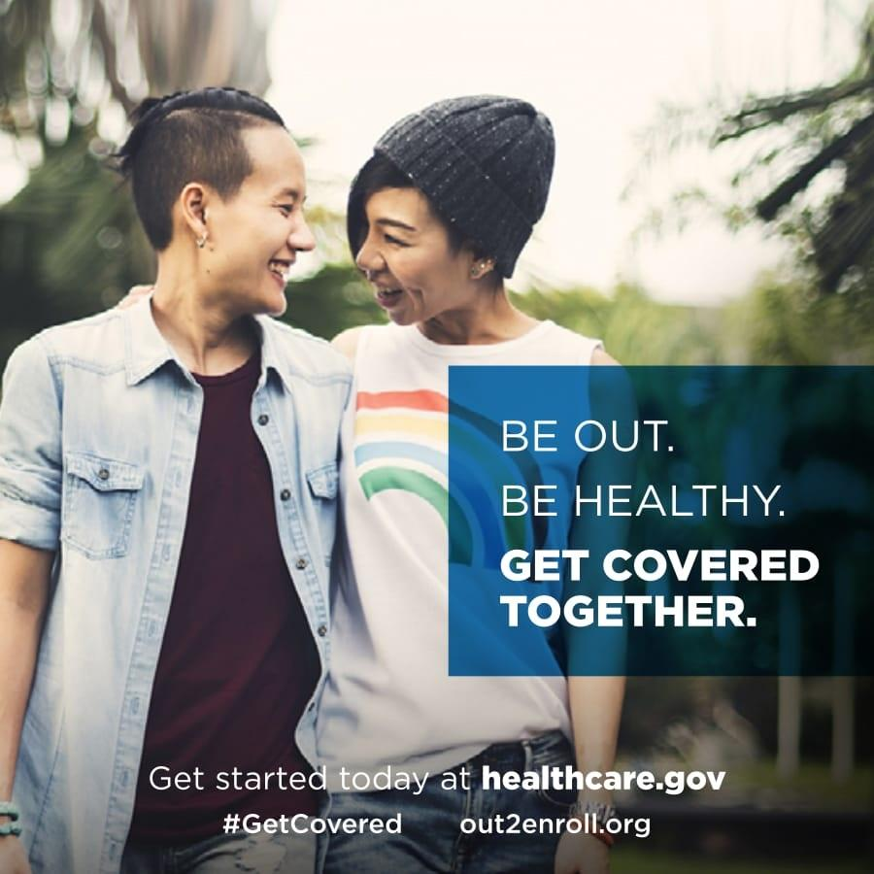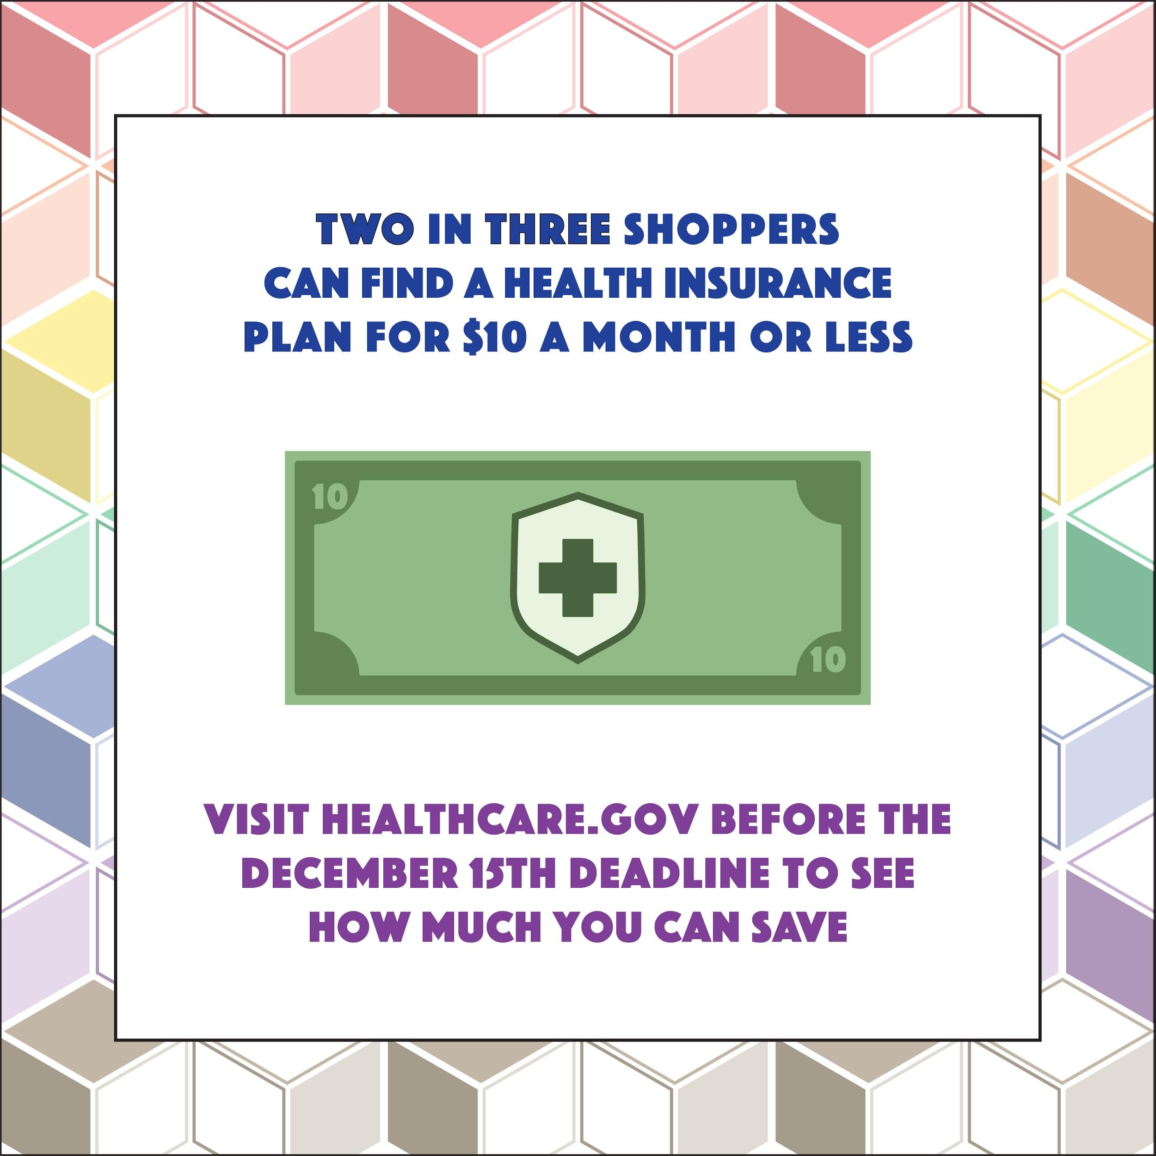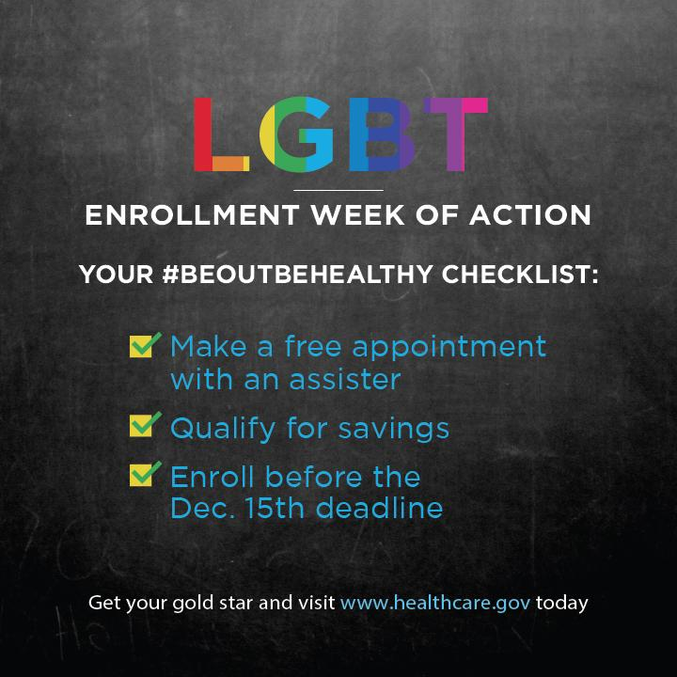

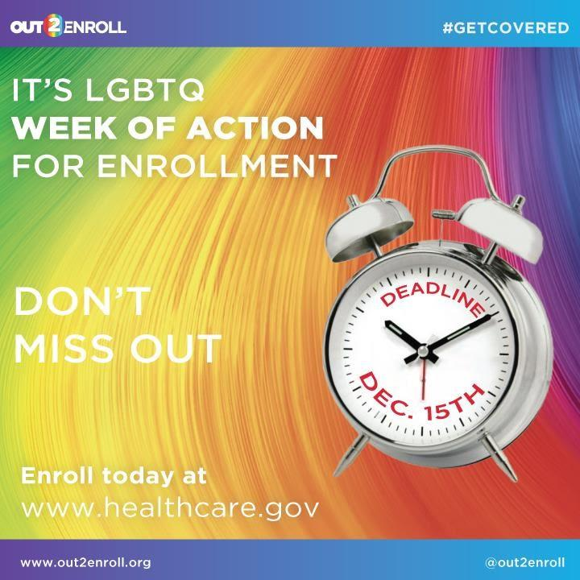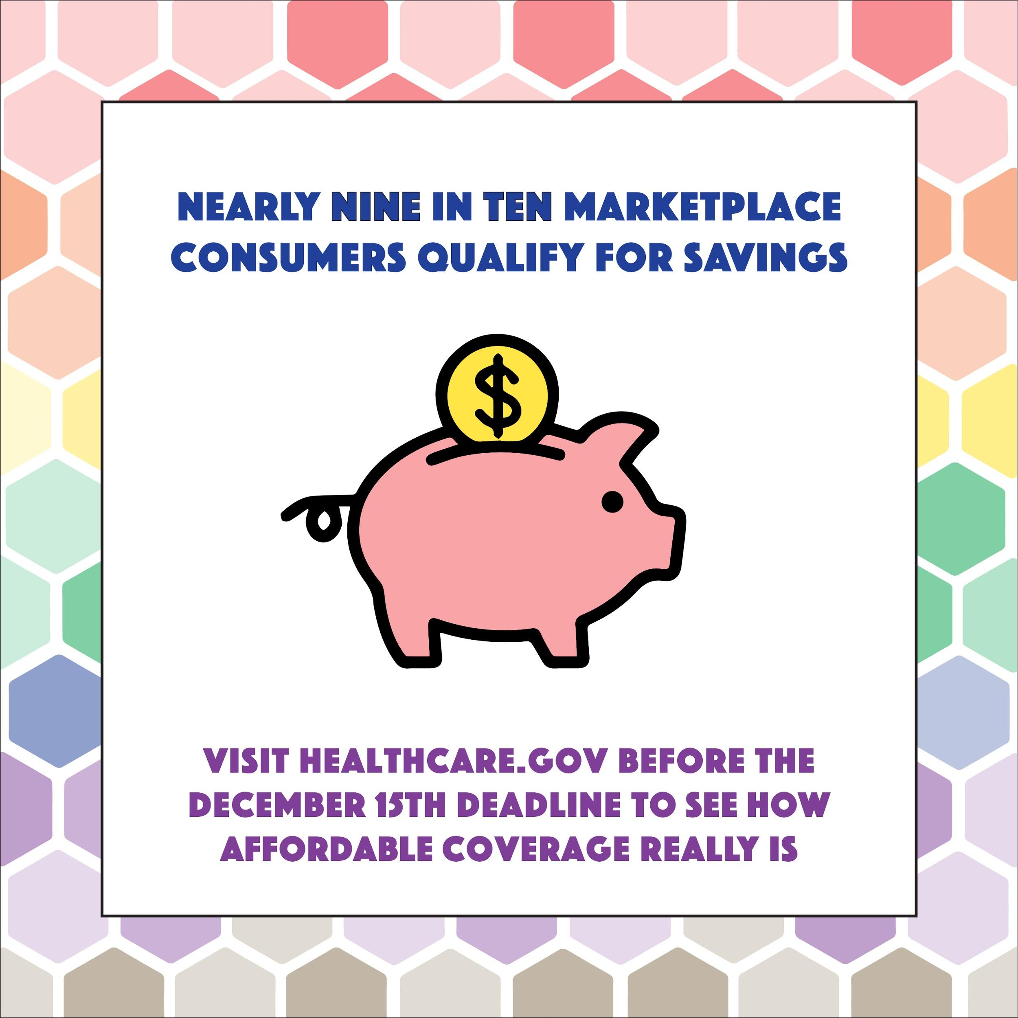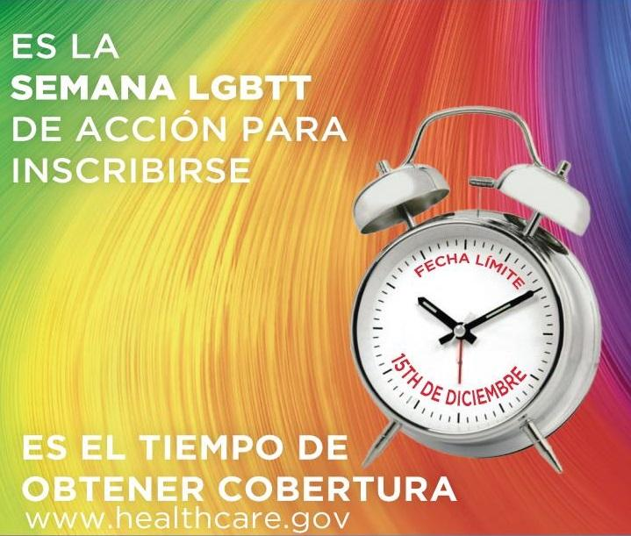

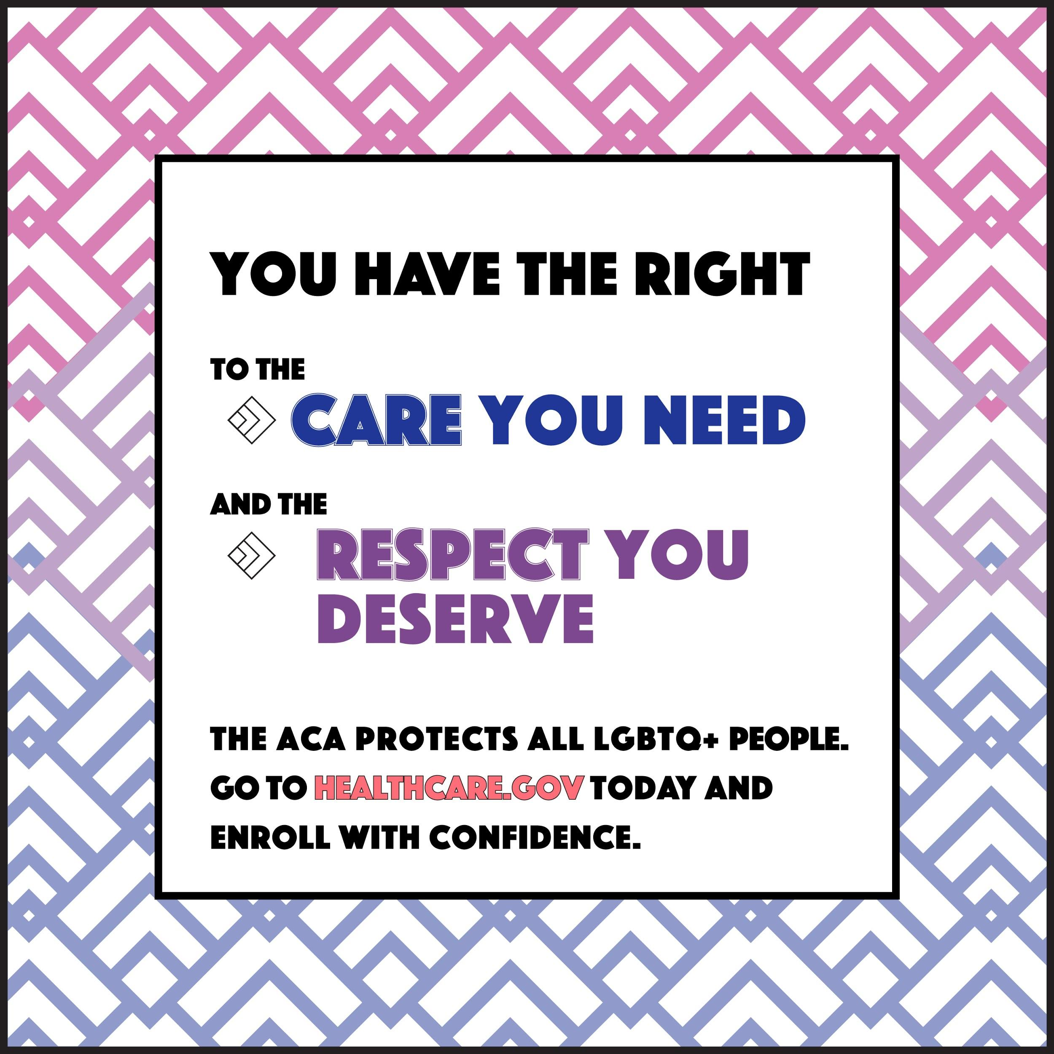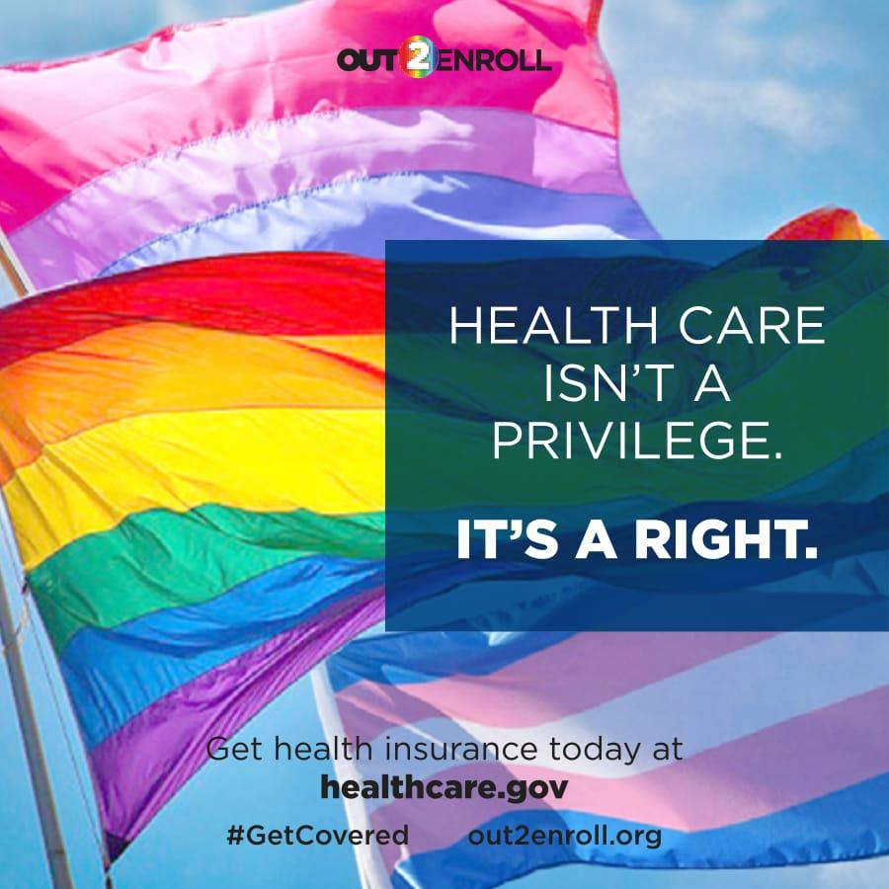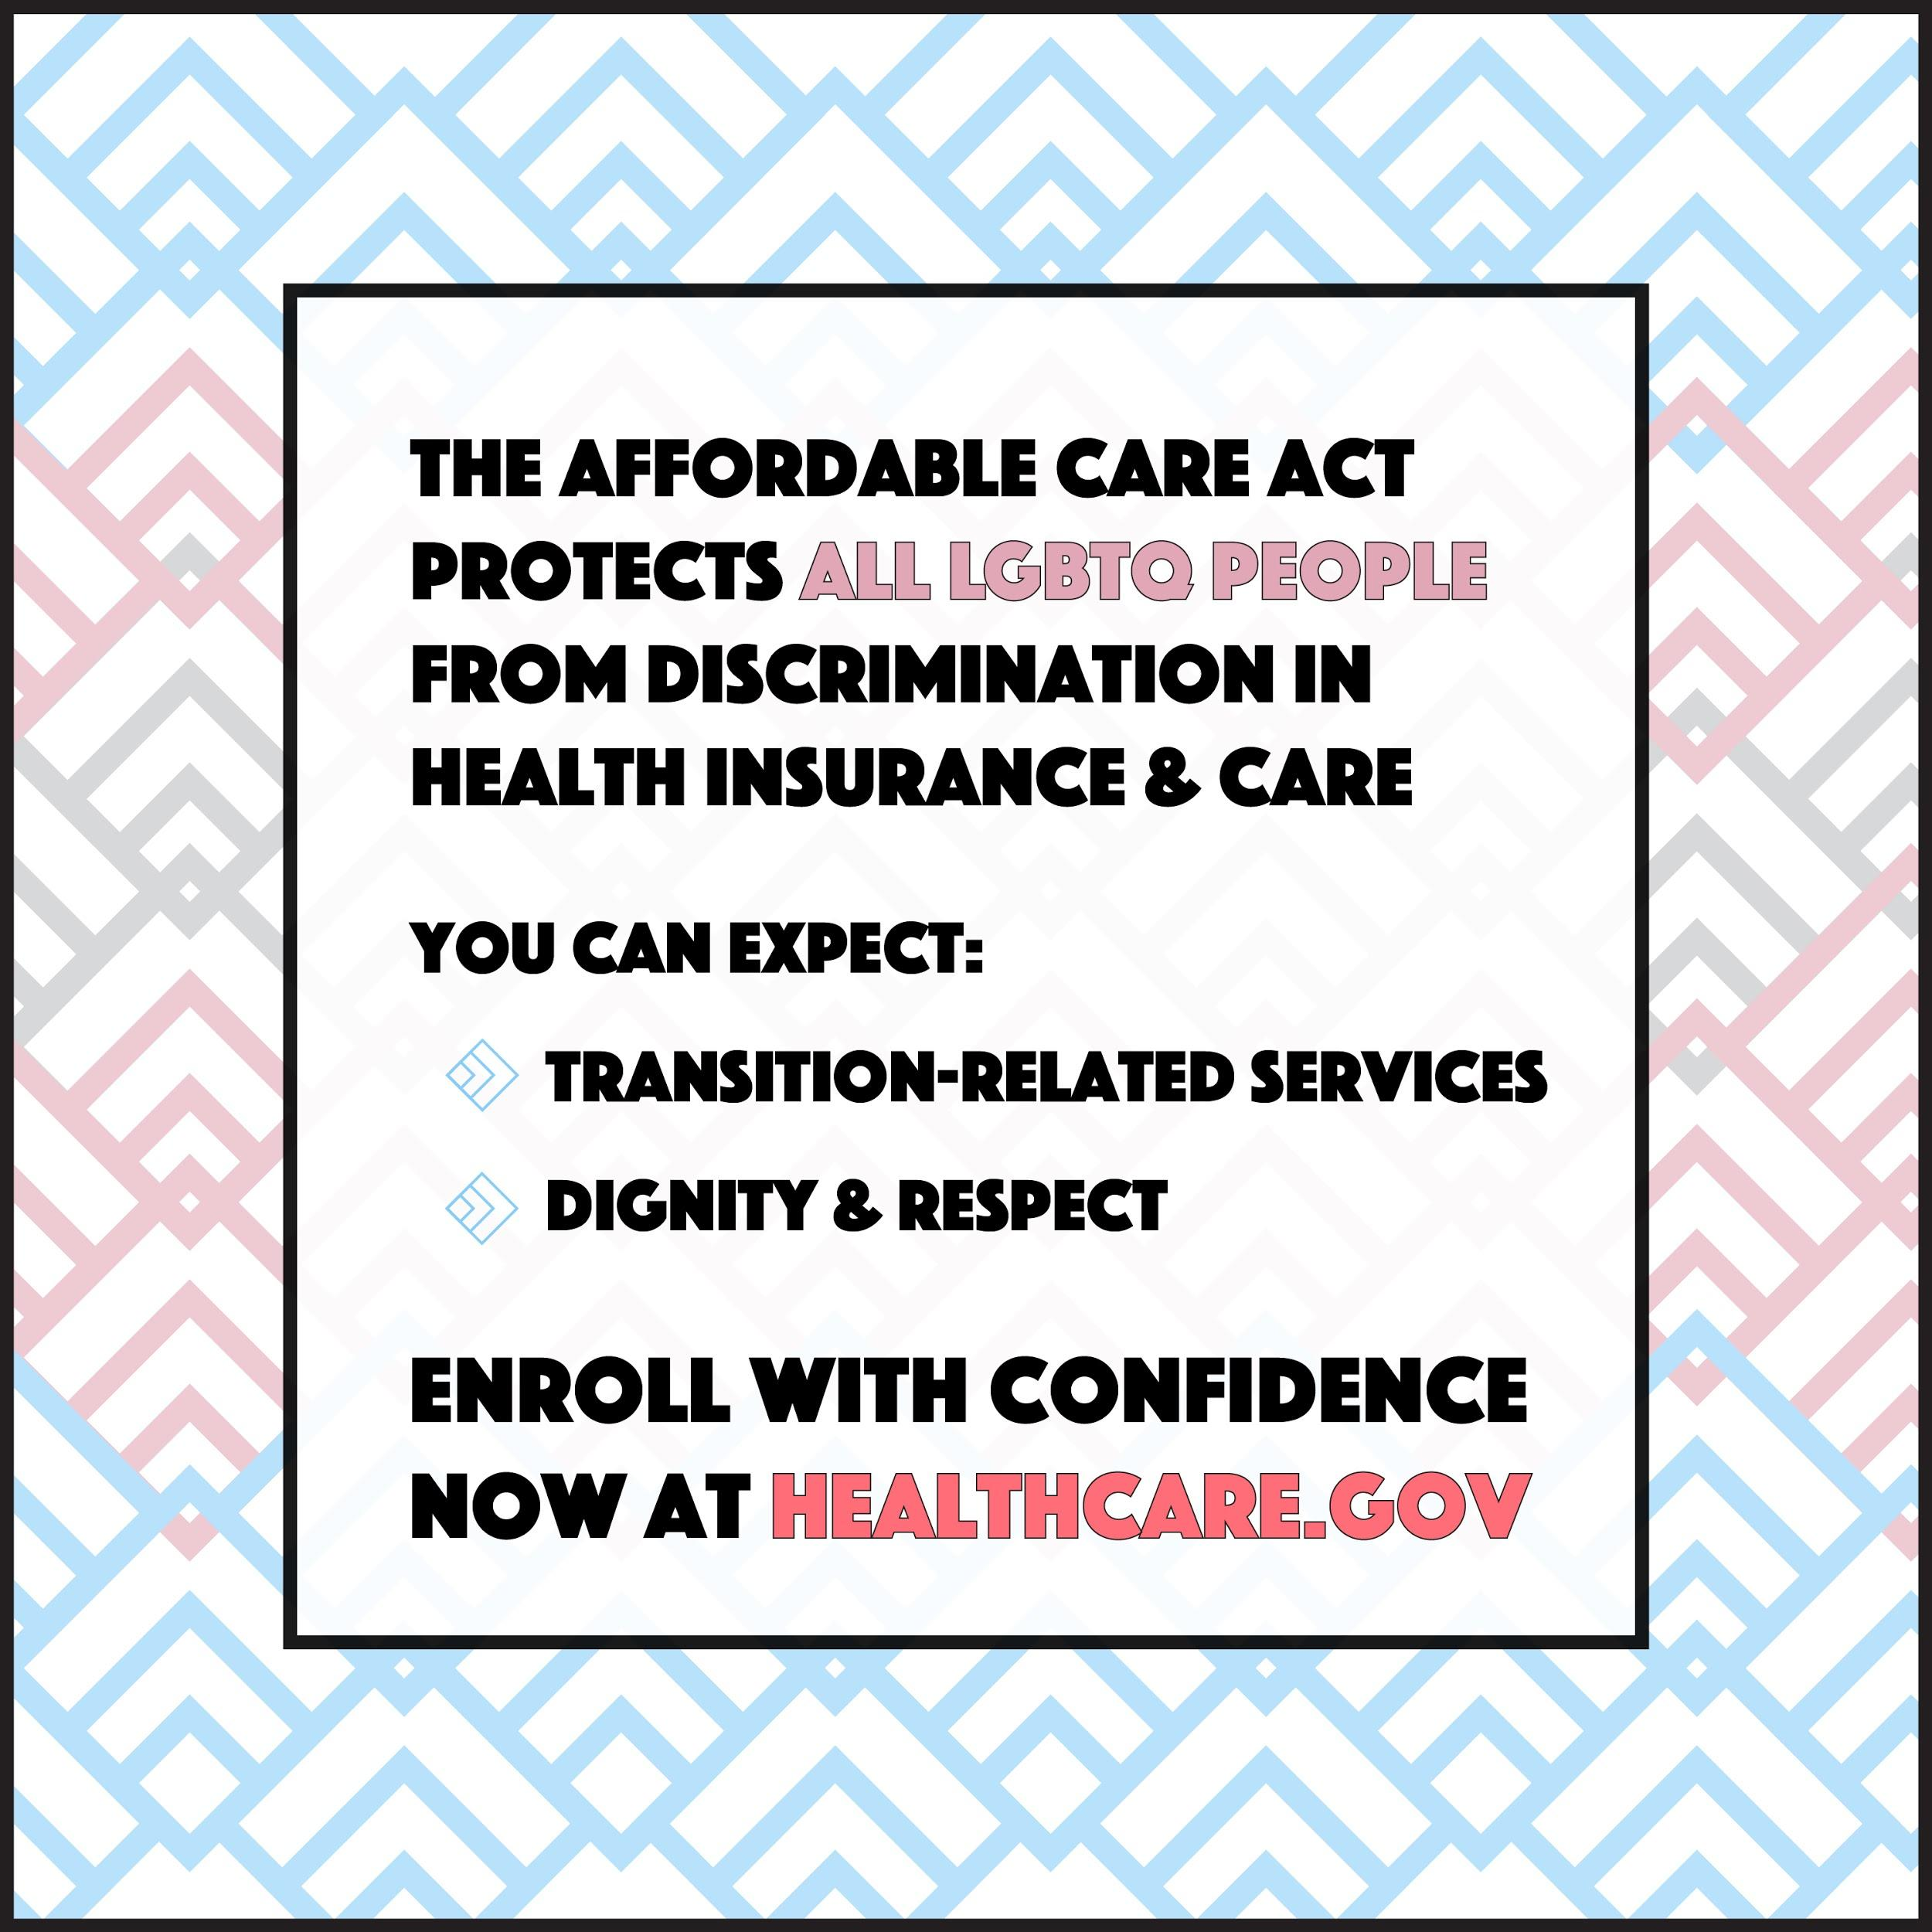
Key Messages
Message testing shows that the best messages are informational and demonstrate confidence and stability in the marketplaces. We must let people know that the marketplaces are once again “open for business” for 2020 coverage. These messages are:
- “The final deadline to enroll is December 15th.” Recent polling data shows that “Even though two open enrollment periods have passed since the new enrollment deadline, a mere 5% of uninsured individuals and know the deadline and less than one in five insured consumers (19%) know the correct date. Messaging around the Dec. 15th deadline remains critical to make sure these consumers don’t miss their opportunity to enroll.
- “Health plans and prices change every year—and the amount of financial help you can get may change too. Visit HealthCare.gov today!” Affordability remains the biggest focus and challenge for returning consumers and the uninsured alike. Many simply won’t enroll if coverage costs too much. Financial help is also the best way to make a distinction between the marketplaces (since consumers can only get subsidies through HealthCare.gov). We recommend messages like “HealthCare.gov is the ONLY place you can get financial help” and “Even if you’ve looked before, it’s time to check out your options and find the plan that’s right for you.”
- “LGBTQ people are protected from discrimination in health care and health insurance.” Although LGBTQ people are under attack by the Trump administration, it is important to remind the community that nothing has changed when it comes to health care. People still have access to financial help for health insurance and should continue to pay their premiums—and Section 1557’s nondiscrimination protections are still in place. Messages like “you should never face health discrimination simply for being who you are” resonate.
- “Health insurance is better than ever for transgender people who can expect more and demand more.” Too few trans people have had real health insurance options because of discriminatory exclusions. But the ACA’s protections still apply to 2020 health insurance plans, so marketplace plans should NOT and largely do NOT have transgender exclusions. Trans consumers should enroll and expect that transition-related health care will be covered. Trans people may still have to fight with their health insurance company by filing an appeal, but if they’ve been holding out, this is the year to enroll.
- “HealthCare.gov offers free help and personal assistance.” Consumers are more likely twice as likely to enroll if they receive in-person help, and 80% of LGBTQ people want to meet with an assister that understands LGBTQ-specific issues. Consumers can find free in-person help using our locator tool: out2enroll.org/enrollment-help. Messages that work well include “signing up is easy” and “you can get free LGBTQ-friendly help from an expert.”
- “HealthCare.gov offers the most comprehensive coverage.” As noted above, we need to continue to regularly push HealthCare.gov as the ONLY place to find high-quality, affordable plans. Consider messages like “Make sure you’re getting the best plan - visit HealthCare.gov today” and “If you’re not visiting HealthCare.gov, you could be missing out on health insurance that covers everything you need.” In addition, you could use “Plans offered at HealthCare.gov cover comprehensive benefits like preventive care, check-ups, prescriptions, mental health care, birth control, and more.”
Key Digital Events
- Dec. 1nd to Dec. 7th: LGBTQ Enrollment Week of Action
  - This week is also AAPI Week of Action and Men’s Health Week!
- Dec. 1st: World AIDS Day
- Dec. 2nd: #MillennialMon Twitter chat on open enrollment (3pm ET)
- Dec. 4th
  - #WellnessWed Twitter chat on open enrollment (2pm ET)
  - UnidosUS open enrollment tele-town hall (7:30pm ET)
- Dec. 6th: National Youth Enrollment Day

Sample Facebook Posts & Tweets
Week of Action:
- FB: It’s #LGBTQ Enrollment Week of Action! This is the best time of year for our community to #GetCovered and save money before the Dec.15th deadline. It's cheaper and easier than ever to get health insurance! Visit HealthCare.gov TODAY #EnrollByDec15
- FB: Es La Semana LGBTT de Acción para Inscribirse. Es el tiempo de obtener cobertura para 2020! Visite cuidadodesalud.gov antes de la fecha límite - 15 de diciembre. #GetCovered!
- Twitter: LGBTQ Enrollment Week of Action is the best time to #GetCovered and save money before the Dec 15 deadline Visit HealthCare.gov to #EnrollByDec15
- Twitter: Es La Semana LGBTT de Acción para Inscribirse. Es el tiempo de obtener cobertura para 2020! Visite cuidadodesalud.gov antes de la fecha límite - 15 de diciembre. #GetCovered!

Dec 15th Deadline:
- FB: Tick tock, tick tock…we’re getting closer to the FINAL DEADLINE to enroll in health insurance through HealthCare.gov. The LAST DAY to enroll is Dec. 15th – so don’t get stuck in line or miss your chance. Visit HealthCare.gov today to get started and give yourself the peace of mind you need #EnrollByDec15
- FB: Don’t delay, enroll today! HealthCare.gov is open for business for 2020 but open enrollment is short this year – the final deadline is Dec. 15th. Don’t be one of those people who waits until it’s almost too late. Visit HealthCare.gov today to #GetCovered and give yourself peace of mind #EnrollByDec15
- FB: DYK: the final deadline to get health insurance for 2020 is Dec. 15th?!? Make sure you have a plan to get the coverage you need before it’s too late. No need to put it off – #GetCovered TODAY at HealthCare.gov #EnrollByDec15
- Twitter: Tick tock, tick tock. We're getting closer to the FINAL deadline to #GetCovered at HealthCare.gov. Don't miss out! #EnrollByDec15
- Twitter: Don’t delay, enroll today! The deadline is Dec. 15th but avoid the rush and #GetCovered TODAY at HealthCare.gov #EnrollByDec15
- Twitter: Need health insurance? RUN, DON'T WALK to HealthCare.gov to find a plan that fits your life and your budget #EnrollByDec15

Financial Help:
- FB: Enrolling in health insurance is cheaper and easier than you think – head to HealthCare.gov today to SHOP and SAVE on health insurance for 2020! #GetCovered #EnrollByDec15
- FB: Worried about costs? Health plans and prices change every year and you could SAVE BIG at HealthCare.gov. See if you qualify for a discount and find a deal TODAY #GetCovered #EnrollByDec15
- Twitter: Enrolling in health insurance is cheaper & easier than you think! Visit HealthCare.gov now to SHOP & SAVE for 2020! #EnrollByDec15
- Twitter: Do you qualify for a discount on health insurance? Most people do! Visit HealthCare.gov TODAY to see if you qualify #EnrollByDec15

Enroll Now:
- FB: Making your holiday list and checking it twice? Don't forget health insurance! #GetCovered for 2020 at HealthCare.gov before the Dec. 15th deadline #EnrollByDec15
- Twitter: Making a holiday list & checking it twice? Don't forget health insurance at HealthCare.gov by Dec. 15th! #GetCovered #EnrollByDec15

Nondiscrimination:
- FB: #TransHealth matters. Thanks to the Affordable Care Act, transgender and genderqueer people should never be discriminated against in health insurance or health care. That means access to the free preventive care and transition-related care you need—and the right to be treated with respect by health care providers. Enroll now at HealthCare.gov before it’s too late #KnowYourRights #GetCovered #EnrollByDec15
- FB: Got questions about health care? Nothing has changed—the Affordable Care Act STILL protects all LGBTQ people from discrimination in health insurance and health care. Enroll now at HealthCare.gov before it’s too late #KnowYourRights and #GetCovered #EnrollByDec15
- FB: We know it can be frustrating to find the health insurance you need, especially for transition-related care. But marketplace plans are better than ever before. Enroll with confidence at HealthCare.gov #KnowYourRights #EnrollByDec15
- Twitter: You have the right to the care you need and the respect you deserve, especially when it comes to #TransHealth. #GetCovered TODAY at HealthCare.gov. #EnrollByDec15
- Twitter: Nondiscrimination protections for #LGBTQ people mean NO #trans exclusions & better coverage. Enroll with confidence at HealthCare.gov #EnrollByDec15
- Twitter: You should NEVER face discrimination no matter who you are or where you live. Visit HealthCare.gov and #EnrollByDec15
LGBTQ Disparities:
- FB: We've got a lot of work to do when it comes to health insurance for bi+, queer, and trans folks in our community. Don't be a statistic - visit HealthCare.gov TODAY to #GetCovered before the Dec. 15th deadline #EnrollByDec15
- Twitter: Why do we want you to #GetCovered? Because our community needs it! Visit HealthCare.gov TODAY #EnrollByDec15

Open Enrollment Includes LGBTQ people:
- FB: Millions have health insurance thanks to the Affordable Care Act, including many LGBTQ people. Now that open enrollment is BACK, make sure you and your loved ones #GetCovered at HealthCare.gov before the December 15th deadline #EnrollByDec15
- FB: We know the headlines can be scary when it comes to health care and being LGBTQ. But the Affordable Care Act protects our community from discrimination in health insurance, at the hospital or clinic, and with our doctors. So #KnowYourRights and #GetCovered at HealthCare.gov before it’s too late #EnrollByDec15
- Twitter: Open enrollment means open for all, including LGBTQ people & families! Spread the word and #GetCovered at HealthCare.gov #EnrollByDec15
- Twitter: All LGBTQ people are protected from discrimination in health insurance and health care. This open enrollment period, find coverage at HealthCare.gov and tell your friends to do the same! #GetCovered #EnrollByDec15

In-Person Help:
- FB: Need help finding health insurance? You're not alone! Let our FREE, unbiased LGBTQ-friendly experts make sure you're getting the best deal and saving the most money by the Dec. 15th deadline. Schedule an appointment today at out2enroll.org/enrollment-help #GetCovered #EnrollByDec15
- FB: Getting health insurance is easier than ever at HealthCare.gov! But we know you've still got questions - if you need a little help, check out our FREE in-person LGBTQ-friendly assisters in your area. Make an appointment today before it’s too late: out2enroll.org/enrollment-help #GetCovered #EnrollByDec15
- FB: Need answers to your trans-related health insurance questions before you choose a HealthCare.gov plan? We can help! Connect for FREE with a trans-friendly expert at out2enroll.org/enrollment-help and #EnrollByDec15
- Twitter: Need LGBTQ-affirming answers to health insurance questions? Connect with a queer-friendly expert at out2enroll.org/enrollment-help #EnrollByDec15
- Twitter: Ready to shop for health insurance at HealthCare.gov? Need extra help? Visit out2enroll.org/enrollment-help to find a FREE LGBTQ-friendly expert to help you #GetCovered #EnrollByDec15
- Twitter: No need to stress about health insurance – we can help! Free queer-friendly help is available at out2enroll.org/enrollment-help! #EnrollByDec15 at HealthCare.gov.

